Estuary
by Ngioka Bunda-Heath
Presented by Darebin Arts Speakeasy & Melbourne Fringe

Social Script

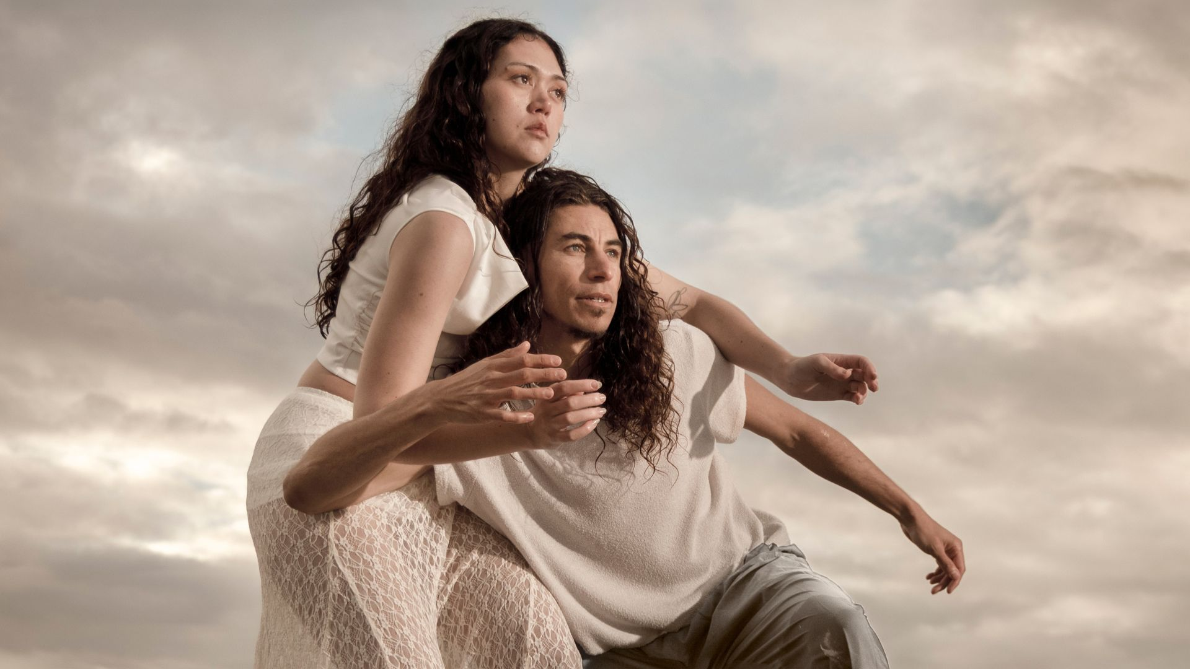

Image credit: James Henry
Image description: Two Aboriginal people wear white outfits. They lean onto one another in a crouching position with arms bent and half raised. Behind them is a cloud-filled sky with pockets of sunshine.

Table of Contents
Where 3
When 3
Access Services 3
Content Warnings 4
Sound 4
Lighting 5
Physical 5
Visual 6
Audience Experience 6
Performance expectations 7
Post-Show Artist Talk: 8
Mob Night: 8
The Venue 9
Front Entrance 9
Accessible Entrance 10
Box Office 11
Ushers 11
Toilets 12
Bar 13
Performance Space 14
Getting to Northcote Town Hall Arts Centre 15
Public Transport Information 15
For help planning your tram, train or bus trip use the PTV journey planner. 15
By Tram 15
By Train 17
By Bus 18
By Car 20
Bike or foot 21

Where
Northcote Town Hall Arts Centre
189 High Street, Northcote Victoria 3070

When
Wednesday 7 October, 7.30pm (Preview)
Thursday 8 October, 7.30pm (Opening)
Friday 9 October, 7.30pm
Saturday 10 October, 2pm (Post-show Artist Talk
Saturday 10 October, 7.30pm (Mob Night)

Duration: 50mins without an interval

Access Services

For more information or to let us know about your access needs, email the ticketing team: Ticketing@darebin.vic.gov.au



The performance is wheelchair accessible.



Northcote Town Hall Arts Centre has accessible toilets on site.


You can book your complimentary companion ticket online or over the phone when purchasing tickets to any show. Contact our box office team for more information.

Performers - Requires an everyday picture of the performer’s face
There are 2 dancers on stage.

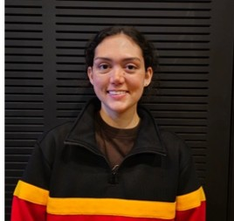

Brooklyn Bond
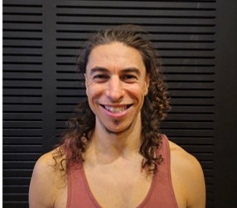

Jack Sheppard

Content Warnings
This event includes audio recordings of the voices of deceased Indigenous persons. this work also contains haze, flickering lights and loud noises.

Sensory Elements

Sound
This production contains a sound scape that is designed to reflect a specific environment. The sounds used in the sound design were recorded from Minjerribah and include:
- Flowing water
- Ripples of water
- Crickets buzzing at Bummeira Lake
- Birds
Infused within these environmental sounds, you will hear instruments: guitars, cellos, clarinets and clapsticks. These instruments provide the rhythm, momentum, texture and materiality to the work.
This work features voices of Aboriginal and Torres Strait Islander people who are no longer with us. These voices are not presented as spoken text or speech but rather as different sonic elements that are embeded into the work. At times they may sound like sirens or ambient drones.
There are moments in the show where you will hear the dancers singing.
At approximately 20-minutes into the work, you will hear a sudden loud noise produced by a bass/percussion. It is synced with the performer’s movements.

Lighting
Throughout the performance, the lighting changes are slow and subtle. Blues and ambers are the main colour pallette, providing calming natural colour tones that compliment the projections.
The work contains the use of projections. The projections are images of natural elements from Minjerribah. The surrounding lights will blackout as images are projected onto the dance floor.
This works contains haze and flickering lights. The lights will flicker at a high bpm rate during the second walking-track section.
At the end of the performance, a 5 second blackout occurs before the lights return and the dancers take their bow.

Physical
The dancers will move in slow, coiling and nuanced movements as they embody natural shapes, pedestrian attitudes that evolve across time and the spirit of saltwater and freshwater.
At approximately 20-minutes into the work, the dancers will begin to move their bodies in syncopated rhythm to create complex push/pull motions. Their movements and bodies will intertwine, representing their ‘estuary’.
They will wear anklets made of raffiah yarn and emu feathers — specific care and consultation regarding the use of these anklets occured during the work’s development.

Visual
Projections will be displayed on the dance floor throughout the performance. During such projections the surrounding lights will black out leaving only the light from the projection to illuminate the stage.
At the beginning of the work a poem overlayed with blue waters from Minjerribah will appear on the dance floor.
At approximately 40-minutes into the work, and lasting for approximately 2-minutes, a very fast-moving projection will appear. This is drone footage, providing a bird’s-eye view of the southern beaches and coastline of Minjerribah. The image runs at a high speed of approximately 60kmph.
This projection will also be accompanied by flashing lights that eb and flow in speed and intensity.

Audience Experience

Entry to Space

The audience will enter the Main Hall from the main doors in foyer.
The performance space will be open 5 minutes prior to start time.
Audiences will be allowed to sit wherever they prefer on the seating bank.
The Main Hall doors will close at the performance start time.
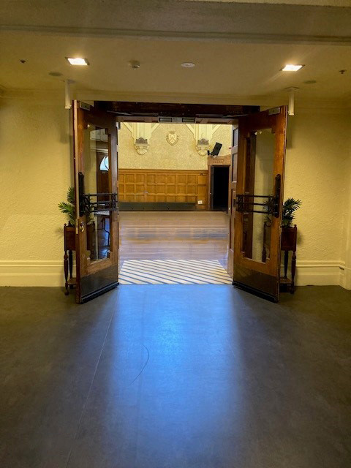
Image: The entrance into the Main Hall at Northcote Town Hall Arts Centre.

There is no allocated seating for this performance. Please let the front of house staff know if you require assistance to your seating. There are designated seats for wheelchair access.
There is/no lock out (or lock in) for this performance. Audience members are welcome to come and go as they please and access the toilets when necessary

Performance expectations
As audiences enter the space, they can expect to encounter a performance environment that feels immersive and atmospheric rather than entering a conventional theatre setting. The dancers will already be present, creating a sense that the work has begun before the audience has taken their seats. Estuary is not a linear story with traditional characters or a beginning, middle and end. Instead, the work unfolds through movement, sound, language, rhythm and imagery. The audience is invited to experience the work through their senses and to make their own connections between the different moments. The recorded songs in my ancestral language are an important part of the soundscape and create a direct connection to lineage and Country. The movement responds to and sits alongside these voices, allowing the cultural and contemporary elements of the work to exist together. The work moves between different states and ideas rather than specific scenes or locations. Water and the meeting of different currents become a way of thinking about connection, family, Country, identity and change. Audiences don't need to know anything about the story beforehand. They are invited to enter the world of Estuary, listen, observe and feel their way through the work. It is a contemporary dance experience that offers a window into my relationship with Minjerribah, Country and lineage, while leaving space for each audience member to create their own interpretation.

General Notes
A recorded Acknowledgement of Country will inside the performance space before the start of the show.

Post-Show Artist Talk:
After the Saturday 10 October, 2pm performance there will be an optional post-show talk with the artists, on the same stage. There will be a short break between the performance and the talk.

If you do not wish to stay for the post-show talk there is no obligation. You are most welcome to stay or leave.

Mob Night:
The Saturday 10 October, 7.30pm performance is an opportunity for Mob community members and allies to attend and enjoy the work within a safe, welcoming and culturally respectful environment. After the performance, the audience is welcome to gather in the bar area to meet with the dancers and creative team. Light refreshments will be served.
If you do not wish to stay there is no obligation. You are most welcome to stay or leave.

The Venue
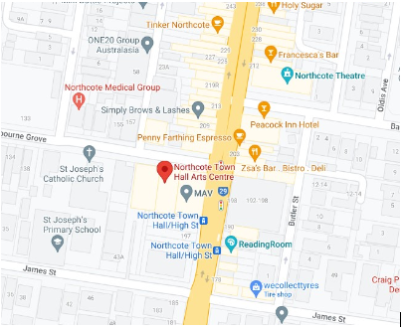
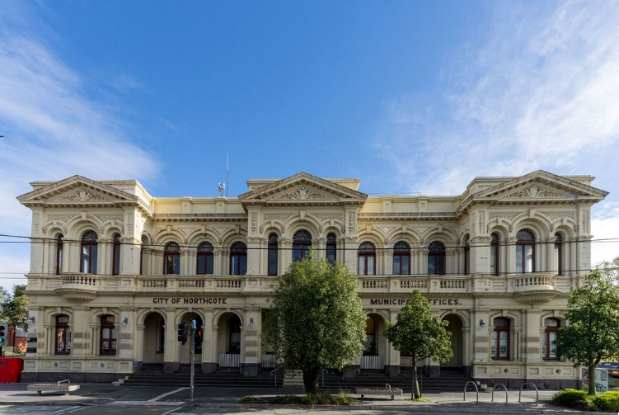
Image: a map of Northcote Town Hall Arts Centre and its surrounding area. Map

Image: Northcote Town Hall Arts Centre as seen from High St, Northcote

Front Entrance
At Northcote Town Hall Arts Centre, the main entrance is up the steps to the side of the building off High St. There are nine steps equipped with grab rails and tactile surface indicators at the top and bottom of each step.

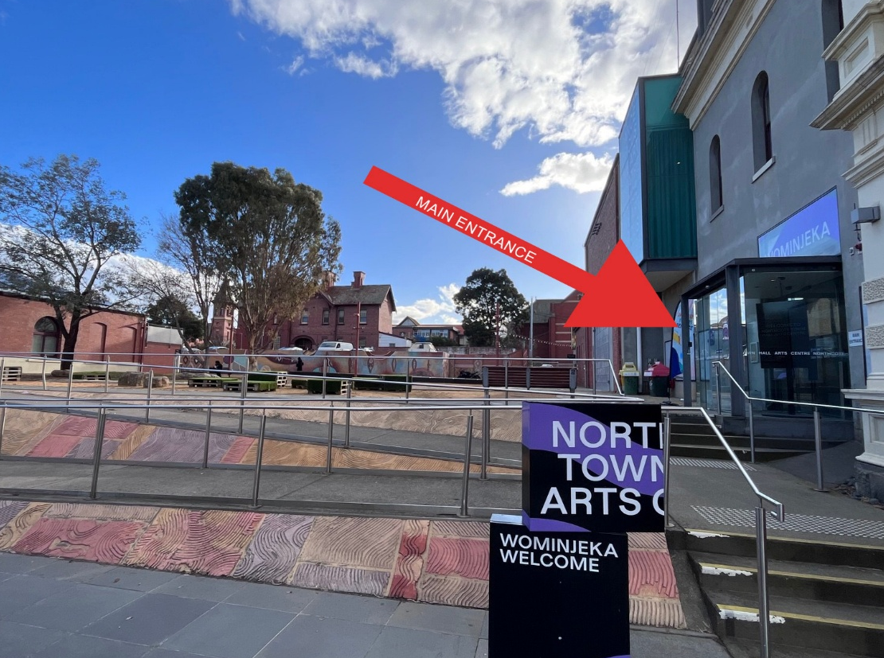

Accessible Entrance

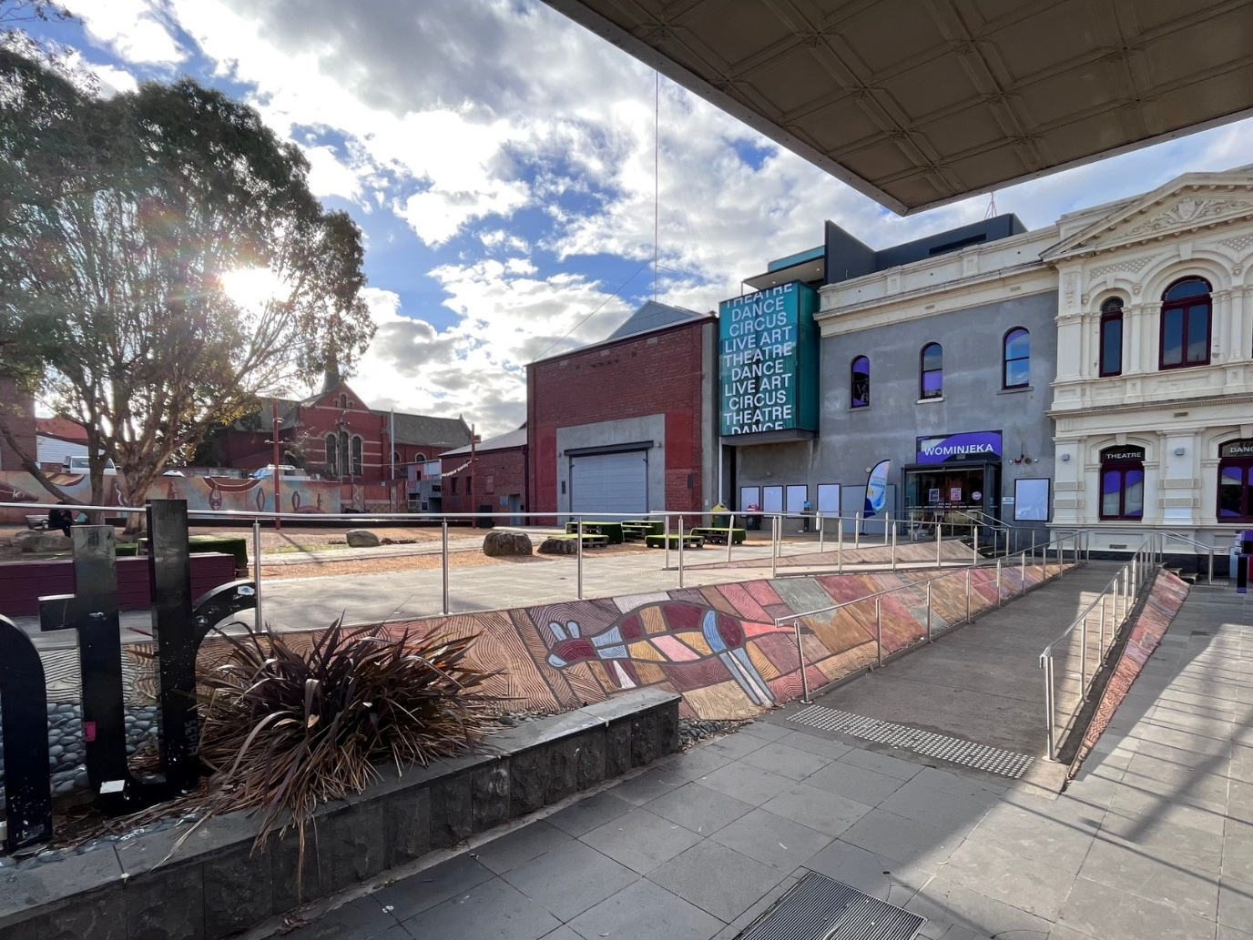

An accessible ramp is located next to the main building entrance.

Box Office
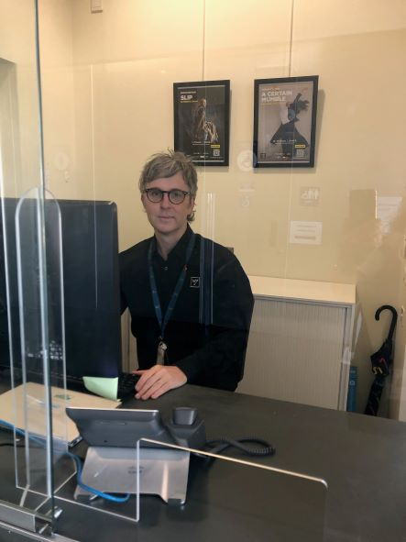
Once inside, the box office to the right of you. Here, our welcoming front of house staff will be available to provide any assistance you need.

Ushers
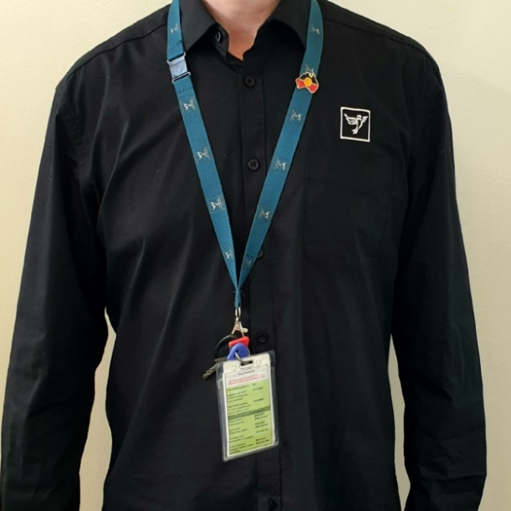
Ushers will be wearing black with a Darebin City Council logo on the left shoulder and a blue lanyard around their neck.

Toilets
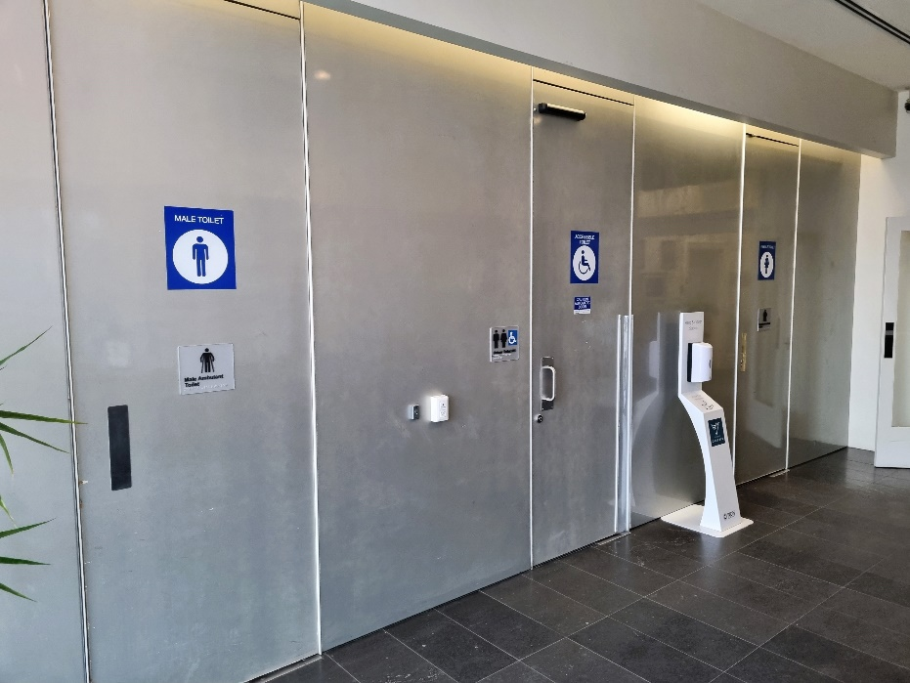

Designated toilets are located to the left once inside the main entrance door and opposite the box office.
All bathrooms have hand dryers with sensory activation.

Bar

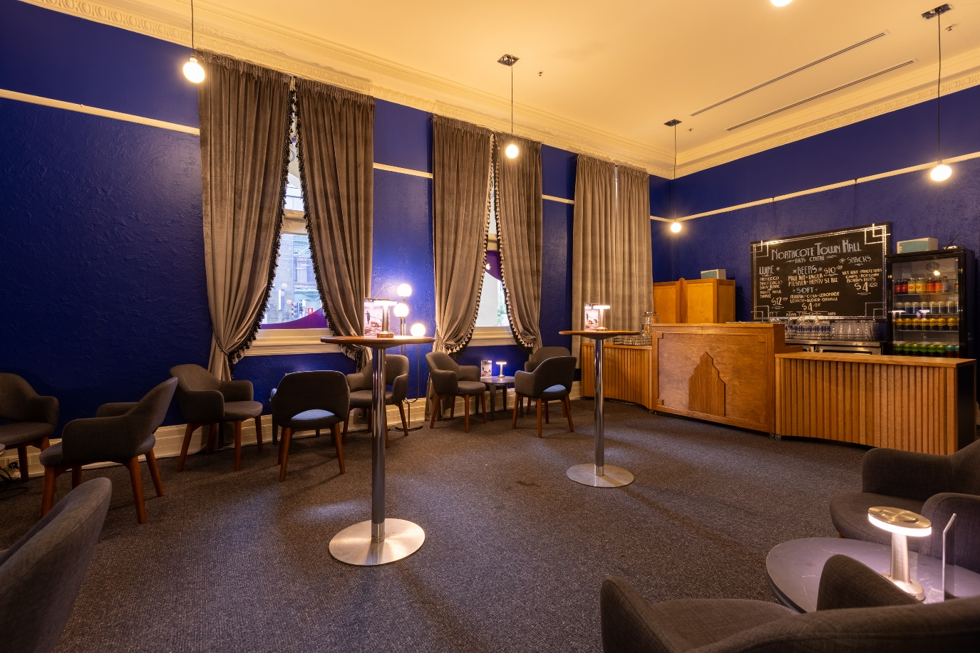
Further down the hall, past the toilets and across from the lift entrance, the bar is located through the doors on the right. Drinks and snacks can be purchased at the bar and taken into the theatre.

There is a lower section of the bar which is wheelchair accessible.
The bar accepts card only, not cash.

After the performance on Saturday 10 Septmber, 7.30pm food and drinks will be displayed at the bar. You are welcome to help yourself to the selection on offer. There is no obligation to stay and mingle after the performance.

Performance Space
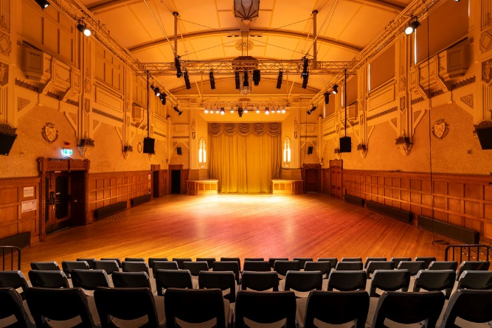

Image: A large art deco hall with seating area in the front.

When the performers are ready, the ushers will announce that the house is open. They will open the doors to the Main Hall, and you may enter at your own pace.

There is general seating for this event. An Usher can help you find a seat if you would like some help. An Usher will also be able to assist those needing wheelchair access into the Main Hall.

Getting to Northcote Town Hall Arts Centre

Public Transport Information
Northcote Town Hall Arts Centre is easily accessible by tram, train, bus, car and bike. Help reduce your environmental impact and rethink your need to drive.

For help planning your tram, train or bus trip use the PTV journey planner.

By Tram
No. 86 (get off at Stop: #31 - Northcote Town Hall/High St.)
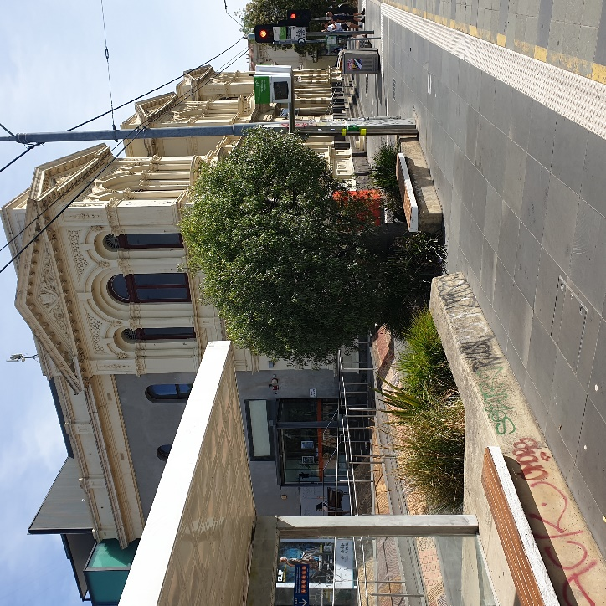

Image Description: Northcote Town Hall Tram Stop #31 (from City)

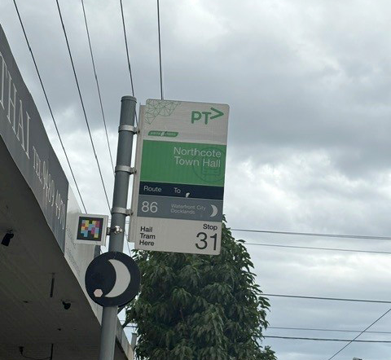

Image: Northcote Town Hall Tarm Stop #31 (from Bundoora RMIT)

Accessibility: Tram stop #31 is a level access stop. There is a tactile ground surface indicator, accessible ramp, and lighting.
YarraTrams aims to run every service on Route 86 with a low-floor tram.
To find out if the next tram at your stop will be a low-floor tram, look for the wheelchair symbol on tramTRACKER® or call 1300 MY TRAM (1300 698 726)

By Train
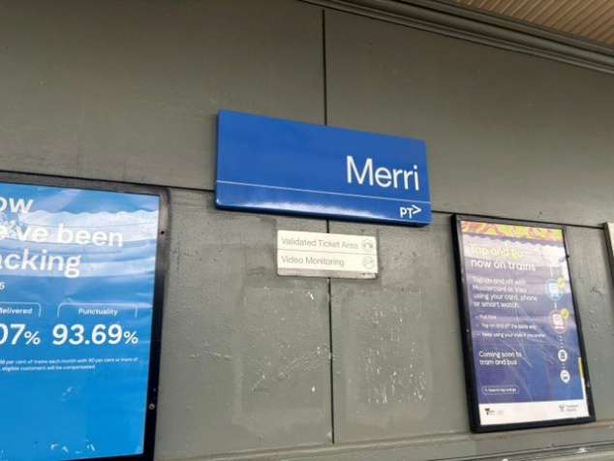

The nearest station is Merri Station, which is a 10 mins walk uphill along James Street, from the venue.

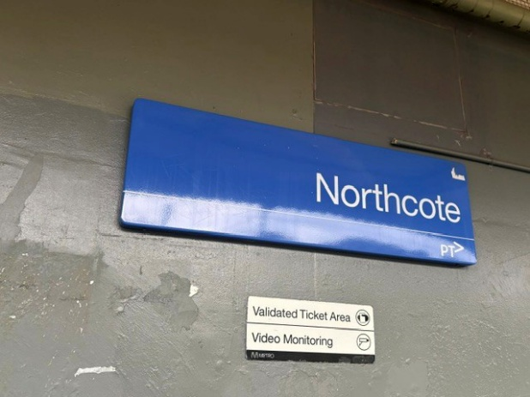
Merri Station Information

Or, Northcote Station, which is a 12 mins walk along High Street from the venue.

Northcote Station Information

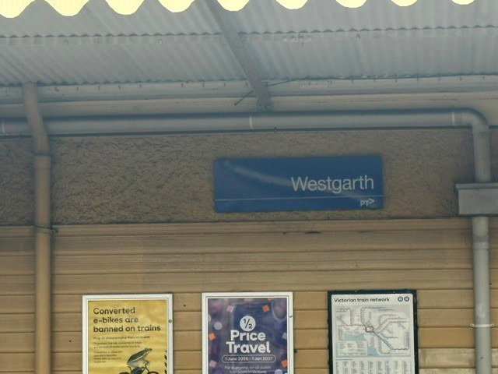

Or, Westgarth Station, which is a 12 mins walk uphill along High Street, from the venue. Or you can catch the No. 86 Tram from Stop: #27 heading towards Bundoora RMIT (Westgarth St/High St) on High St, the get off at stop #31 Northcote Town Hall/High St.

Westgarth Station Information

By Bus

Route 552 (get off at stop 235 Northcote Plaza, and a further 10-minute walk)
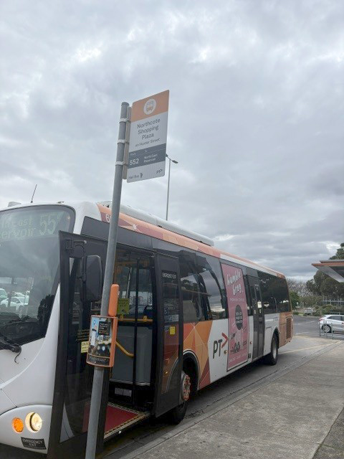

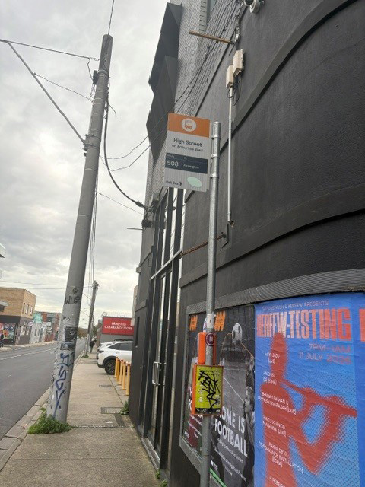
Route 508 (get off at stop 6170 Separation St/High St, and a further 10-minute walk)

Route 567 (get off stop 1036 Mitchell Street/High St, and a further 10-minute walk)
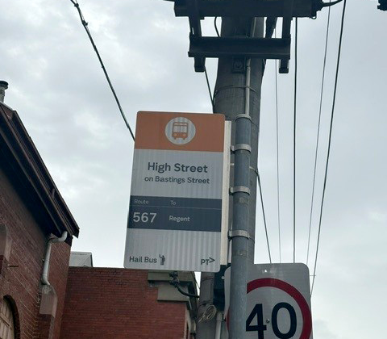

Route 250 and 251 (get off at Westgarth St/High St, and a further 10-minute walk up the hill)
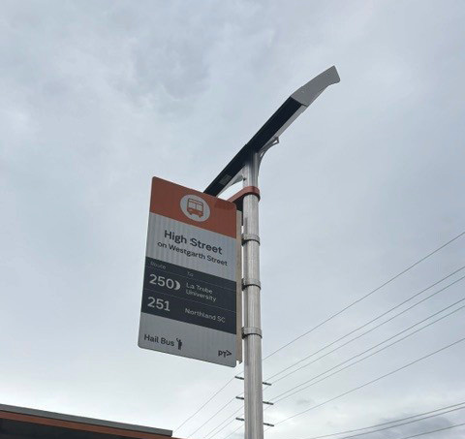

By Car

Limited on-street parking is available on James Street, McIntosh Street and
Westbourne Grove.
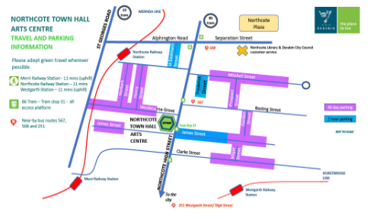

Image: A map of street parking around Northcote Town Hall Arts Centre.

Parking and Disability Access Parking:
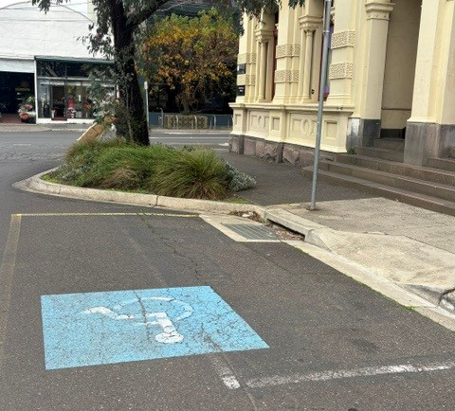
There are two sets of accessible car spaces around the venue: one on James Street, near the corner of High Street, and one on Westbourne Grove, near the corner of High Street.

Image: Accessible parking space on Westbourne Street

Bike or foot
Northcote Town Hall Arts Centre is conveniently located along High Street, Northcote, which is ideal for cycling or walking

