**Wicked Words**  
Presented by Tiger Salmon and Archer Magazine with Darebin Arts

Social Script

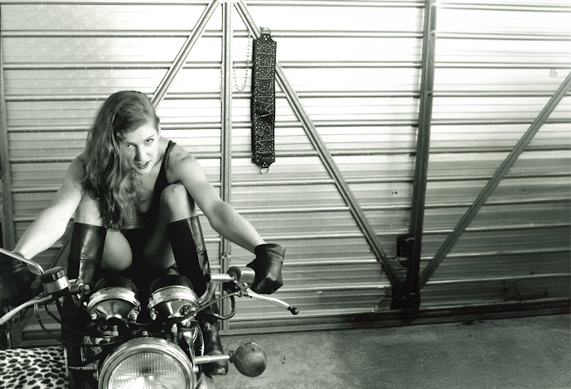

**Image credit**: Skye Wansey Ms Wicked 1993 photographed by Jamie Dunbar for Wicked Women Magazine

**Image description**: A black and white photograph of a woman with long light hair sitting on a motorcycle. She is wearing a black tank top, black tall boots and black gloves. Behind her is a metal wall with a sign hanging that reads, ‘Ms Wicked’.

Table of Contents

Table of Contents 2

**When** 3

**Access Services** 3

**Covid Safety** 3

Sound – 4

Lighting – 4

Physical – 4

Visual – 4

Audience Experience 5

Shocks or surprises 5

Audience experience 6

Social expectations 6

Performance expectations 6

Front Entrance 7

Accessible Entrance 7

Ushers 8

Toilets 10

Performance Space 11

**Getting to Northcote Town Hall Arts Centre** 12

Public Transport Information 12

For help planning your tram, train or bus trip use the PTV journey planner. 12

By Tram 12

By Train 13

By Bus 13

By Car 13

Bike or foot 14

**Where**

Northcote Town Hall Arts Centre

189 High Street, Northcote Victoria 3070

# **When**

Thursday 23 January 2025, 7.30pm

Doors will open at 7pm for a 7.30pm start

Duration: 180mins

# **Access Services**

For more information or to let us know about your access needs, email the ticketing team: [Ticketing@darebin.vic.gov.au](mailto:Ticketing@darebin.vic.gov.au)



The performance is wheelchair accessible.



Northcote Town Hall Arts Centre has accessible toilets on site.



You can book your complimentary companion ticket online or over the phone when purchasing tickets to any show. Contact our box office team for more information.

# **Covid Safety**

The health and safety of our community members is our number one priority.

* We will have air-purifiers running in the venue throughout the event.
* Free masks and sanitizers will be made available
* We recommend wearing a mask for those who are able
* We ask that all visitors continue to practice good hygiene inside the venue.
* We recommend that ticketholders test before attending and stay home if you are feeling unwell or showing symptoms.

As the ticketholder, please ensure all those in attendance in your booking are aware of these recommendations, our terms and conditions and any warnings associated with the event.   
  
If you have any questions please contact: [ticketing@darebin.vic.gov.au](mailto:ticketing@darebin.vic.gov.au).

## **Performers and Speakers**

There are 6 storytellers, an emcee and a DJ.

# 

**Sensory Elements**

## Sound

The emcee and storytellers will use a microphone to amplify their voices. There will be six stories of approximately eight minutes duration each. There will be an intermission break after the third speaker. The stories will be followed by dance party music.

## Lighting

Those on stage will be lit brightly, with level low house lights in seated and bar areas. A disco ball will reflect coloured lights. No strobe lights are planned for the evening.

## Physical

This event is designed for the audience to stand during the performance. There will be limited chairs available to those who require seating. If you require a seat, please speak to the Front of House ushers on arrival.

The audience is seated at tables and booths throughout the space. Standing room at the back.

## Visual

The storytellers and AUSLAN interpreter will appear on an elevated stage. Behind them will appear images projected onto a large screen.

## Audience Experience

**Entry to Space**

The audience will enter the Main Hall from the main doors in foyer.

The performance space will be open 5 minutes prior to start time.

Audiences will be allowed to sit wherever they prefer on the seating bank.

The Main Hall doors will close at the performance start time.

**Image:** Entrance to the Main Hall atNorthcote Town Hall Arts Centre.

## Shocks or surprises

Content warnings will be given at the beginning of the evening explaining that the stories contain explicit content suitable for adults 18+. Topics may include sexuality, sex work, kink positive activity between consenting adults. Images will include nudity and sexually explicit activity.

## Audience experience

While speakers are sharing stories, the space is usually quieter. The audience is requested to lean in and listen closely to stories being shared. It takes a level of courage to get up on stage in front of our peers to share stories from real life. We request that you respect this.

## Social expectations

Patrons are encouraged to take responsibility for their needs. You are free to move as necessary and remove yourself from the room if needed. Patrons are encouraged to respond audibly to stories with applause, laughter, cheering and stomping of feet.

## Performance expectations

There will be six stories of approximately eight minutes duration each with emcee introductions between each speaker. There will be an intermission break after the third speaker. The stories will be followed by dance party and time for patrons to mingle.

**Entry to Quiet Space**

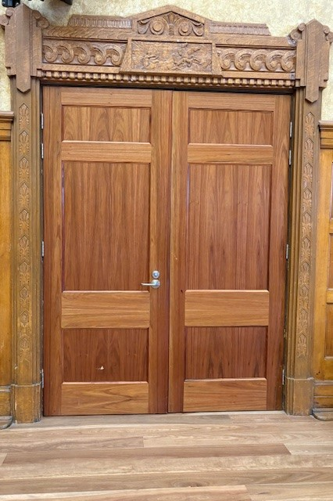

**Image:** Entrance to the Quiet Space from within the Main Hall atNorthcote Town Hall Arts Centre.

A Quiet Space will be accessible throughout the performance. This space is for those who require a break from overstimulation at any time throughout the performance. An Usher will be standing outside the entrance door to lead you inside.

General Notes

An Acknowledgement of Country will be said by a Darebin staff member before the doors to the Main Hall open.

**The Venue**

## Front Entrance

At Northcote Town Hall Arts Centre, the main entrance is up the steps to the side of the building off High St. There are nine steps equipped with grab rails and tactile surface indicators at the top and bottom of each step.

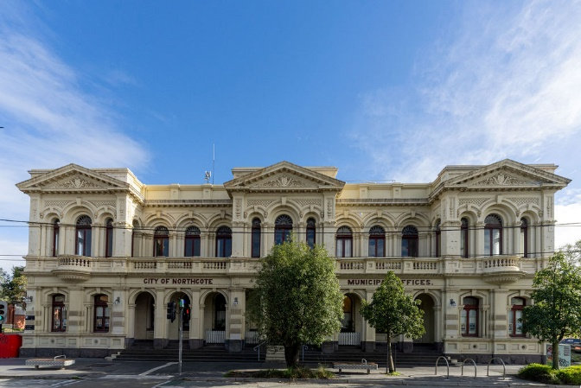 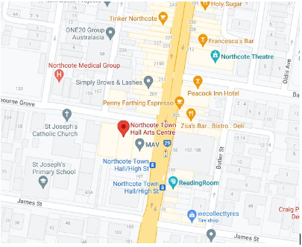

**Image:** Northcote Town Hall Arts Centre as seen from High Street in Northcote.

**Image:** A map ofNorthcote Town Hall Arts Centre and its surrounding area. [map](https://www.google.com/maps/place/Northcote+Town+Hall+Arts+Centre/data=!4m2!3m1!1s0x0:0x4695de3e1d26cbc7?sa=X&ved=1t:2428&ictx=111)

## 

## Accessible Entrance

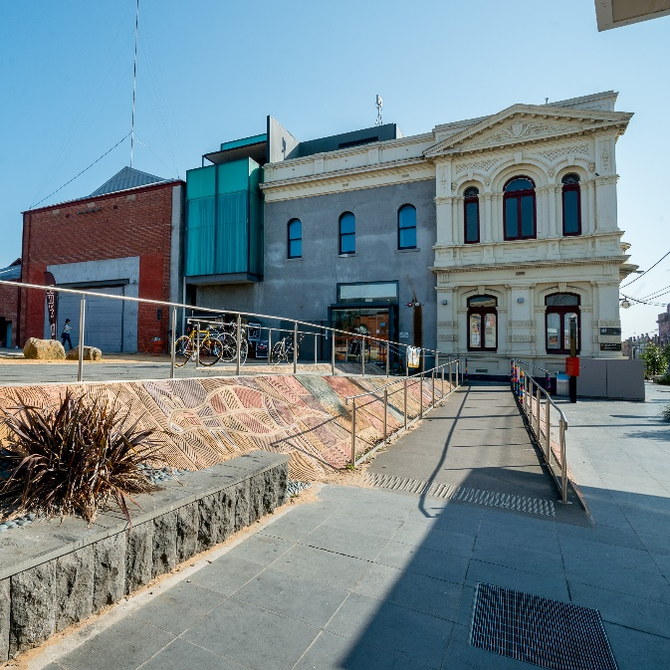

**Image**: Accessibility ramp to the main entrance of Northcote Town Hall Arts Centre as seen from High Street Northcote.

An accessible ramp is located next to the main building entrance. The entrance to the is one single level.

e

**Image**: A person with grey shaggy hair and black shirt sitting behind the glass window of the box office.

Once inside, the box office to the right of you. Here, our welcoming front of house staff will be available to provide any assistance you need.

## Ushers

**Image**: The Darebin Arts staff uniform: a black long sleeve shirt and blue lanyard hanging from the neckline. 

Ushers will be wearing black with a Darebin City Council logo on the left shoulder and a blue lanyard around their neck.

Bar

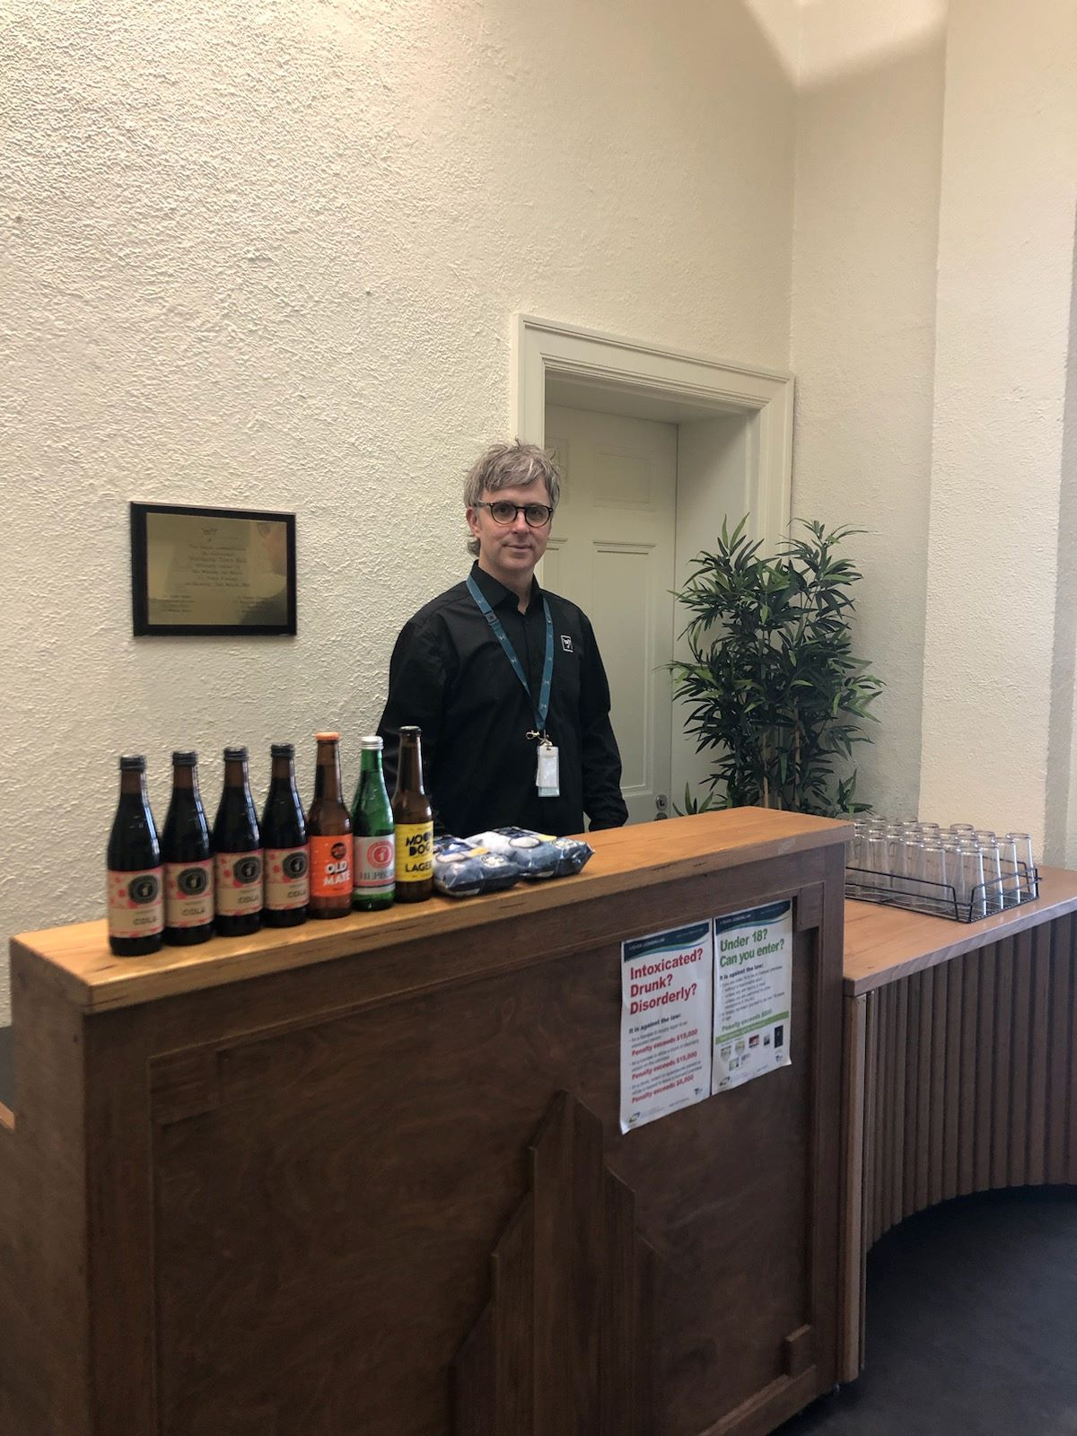

**Image**: A person wearing black framed glasses stands behind a bar counter carrying 6 bottle-necked bottles. 

Drinks and snacks can be purchased at the bar and taken into the theatre.

There is a lower section of the bar which is wheelchair accessible.

The bar accepts card only, not cash.

## Toilets

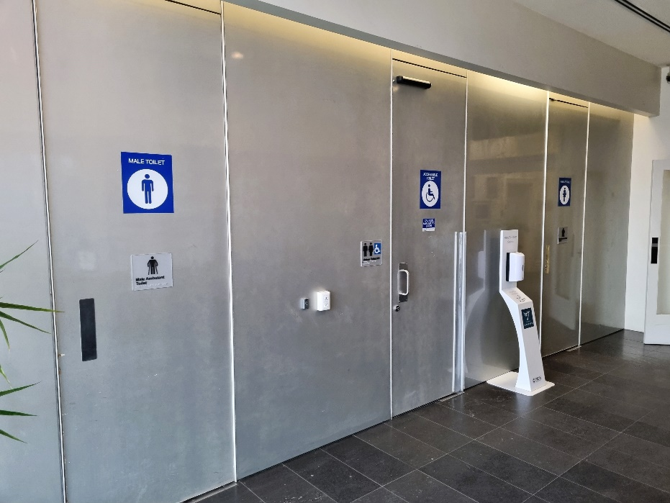

**Image**: The front entrances to the gendered toilets in the main foyer at Northcote Town Hall Arts Centre. 

Designated toilets are located down the main hall of the West Wing and on the left.

All bathrooms have hand dryers with sensory activation.

## Performance Space

When the performers are ready, the ushers will announce that the ‘house is open’. They will open the doors to the Main Hall, and you may enter at your own pace.

**Image**: The entrance into the Main Hall at Northcote Town Hall Arts Centre.

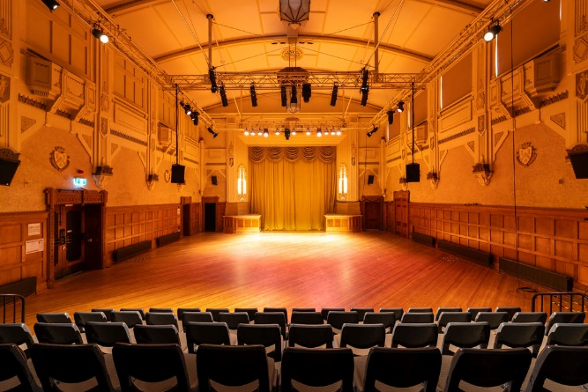

**Image**: A large art deco hall with seating area in the front.

There is general seating for this event. An Usher can help you find a seat if you would like some help. An Usher will also be able to assist those needing wheelchair access into Studio One.

# **Getting to Northcote Town Hall Arts Centre**

## Public Transport Information

Northcote Town Hall Arts Centre is easily accessible by tram, train, bus, car and bike. Help reduce your environmental impact and rethink your need to drive.

## For help planning your tram, train or bus trip use the [PTV journey planner](https://www.ptv.vic.gov.au/journey).

## By Tram

No. 86 (get off at Stop: #31 - Northcote Town Hall/High St.)

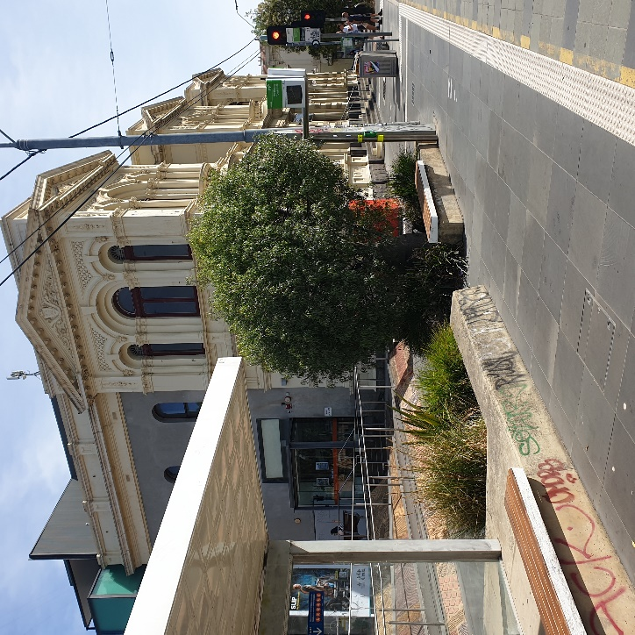

**Image**: Northcote Town Hall Tram Stop #31 (from City)

Accessibility: Level access stop. Tactile ground surface indicator, accessible ramp, lighting,

Yarra Trams aims to run every service on Route 86 with a low-floor tram.

To find out if the next tram at your stop will be a low-floor tram, look for the wheelchair symbol on [tramTRACKER®](http://tramtracker.com/) or call 1300 MY TRAM (1300 698 726)

## By Train

The nearest station is Merri Station, which is a 10 min walk uphill, from the venue.

[Merri Station Information](JourneyPlannerForm:::lat=-37.7778435&lon=144.992981&origin=Merri%20Station&origin_id=1125&_auth=0642fe4d1eed8fce4ec2b672581564d)

Or, Northcote Station, which is a 12 min walk from the venue

[**Northcote Station Information**](JourneyPlannerForm:::lat=-37.7698631&lon=144.995285&origin=Northcote%20Station&origin_id=1147&_auth=d7b8b28d9956c8032fe67b06b36)

Or, Westgarth Station, which is a 12 min walk uphill, from the venue or you can catch the No. 86 Tram from Stop: #27 (Westgarth St/High St) on High St up the hill to the venue (Stop: #31 Northcote Town Hall/High St).

[**Westgarth Station Information**](https://www.metrotrains.com.au/stations/westgarth/)

## By Bus

Route 552 (get off at stop 235 Northcote Plaza, and a further 10-minute walk)

Route 508 (get off at stop 6170 Separation St/High St, and a further 10-minute walk)

Route 567 (get off stop 1036 Mitchell Street/High St, and a further 10-minute walk)

Route 250 and 251 (get off at Westgarth St/High St, and a further 10-minute walk up the hill)

## By Car

There are two sets of accessible car spaces around the venue: one on James Street, near the corner of High Street, and one on Westbourne Grove, near the corner of High Street.

**Parking and Disability Access Parking:**

Limited on-street parking is available on James Street, McIntosh Street and

Westbourne Grove.

## Bike or foot

Northcote Town Hall Arts Centre is conveniently located along High Street, Northcote, which is ideal for cycling or walking

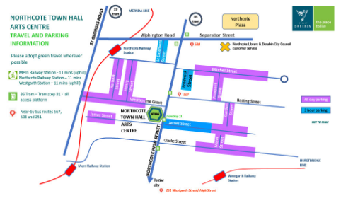

**Image**: A colourful map of available street parking near Northcote Town Hall Arts Centre.