**FRITZ**

by Emilie Bloom & Clare Bartholomew  
Presented by Darebin Arts



Social Script

**Image credit**: Darren Gill  
**Image description**: A person wearing a white rabbit outfit holds a fanned-out deck of large playing cards. Behind them is a red theatre curtain and a large poster with the words ‘Magic Show’ on it.

Table of Contents

**Where** 3

**When** 3

**Access Services** 3

**Entry to Space** 4

Audience experience 5

Social expectations 5

**Other** 5

Front Entrance 6

Accessible Entrance 7

Box Office 7

Ushers 8

Kiosk 8

Toilets 9

**Getting to Northcote Town Hall Arts Centre** 11

Public Transport Information 11

For help planning your tram, train or bus trip use the PTV journey planner. 11

By Tram 11

By Train 12

By Bus 12

By Car 12

Bike or foot 13

# **Where**

Northcote Town Hall Arts Centre

189 High Street, Northcote Victoria 3070

# **When**

Tuesday 8 April, 10am  
Wednesday 9 April, 10am   
Thursday 10 April, 10am

Duration: 50mins without an interval

# **Access Services**

For more information or to let us know about your access needs, email the ticketing team: [Ticketing@darebin.vic.gov.au](mailto:Ticketing@darebin.vic.gov.au)



The performance is wheelchair accessible.



Northcote Town Hall Arts Centre has accessible toilets on site.



You can book your complimentary companion ticket online or over the phone when purchasing tickets to any show. Contact our box office team for more information.

**Performer**

There is 1 performer.

Emilie Bloom

# **Entry to Space**

The audience will enter Studio One from the main doors in West Wing foyer.

The performance space will be open 5 minutes prior to start time.

Audiences will be allowed to sit wherever they prefer on cushions on the seating bank, bean bags on the floor, or chairs on the floor.

Studio One doors will close at the performance start time.

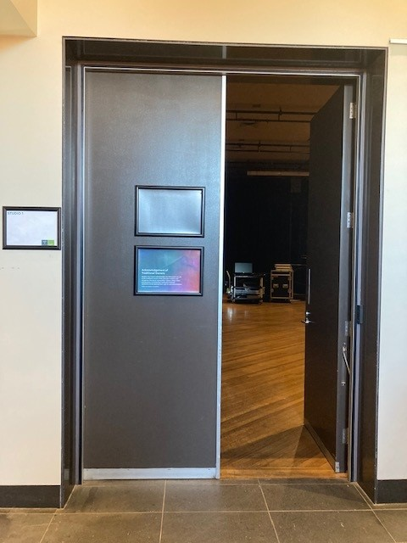

**Image**: Studio One entrance from within the foyer of the West Wing at Northcote Town Hall Arts Centre.

## Audience experience

When summoned by the performer, a chosen audience member is invited to come onto the stage to help Fritz with a magic trick. There is no obligation to assist if uncomfortable.

## Social expectations

During the performance, carrots are offered to the audience as prizes.

# **Other**

Dynamic Sights and Smells

The use of haze occurs at the beginning of the show.

General Notes

An Acknowledgement of Country will be said by a Darebin staff member before the doors to the Main Hall open.

**The Venue**

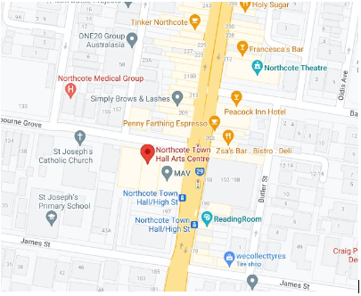

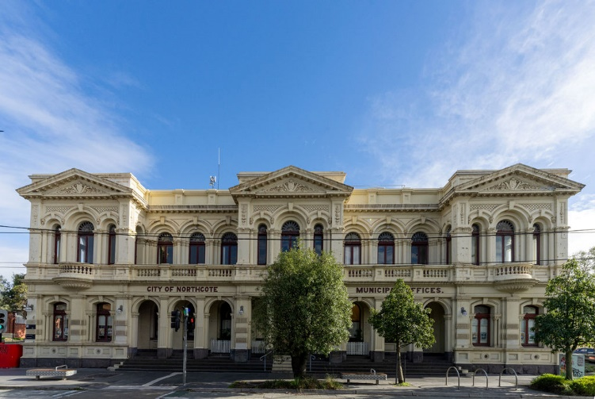

Image: a map of Northcote Town Hall Arts Centre and its surrounding area. [Map](https://www.google.com/maps/place/Northcote+Town+Hall+Arts+Centre/@-37.7744444,144.9975,15z/data=!4m2!3m1!1s0x0:0x4695de3e1d26cbc7?sa=X&ved=1t:2428&ictx=111)

Image: Northcote Town Hall Arts Centre as seen from High St, Northcote

## Front Entrance

At Northcote Town Hall Arts Centre, the main entrance is up the steps to the side of the building off High St. There are nine steps equipped with grab rails and tactile surface indicators at the top and bottom of each step.

**Image**: The West Wing entrance at Northcote Town Hall Arts Centre.

The entrance to the West Wing is beyond the main building entrance. The West Wing is where Studio One is located.

## Accessible Entrance

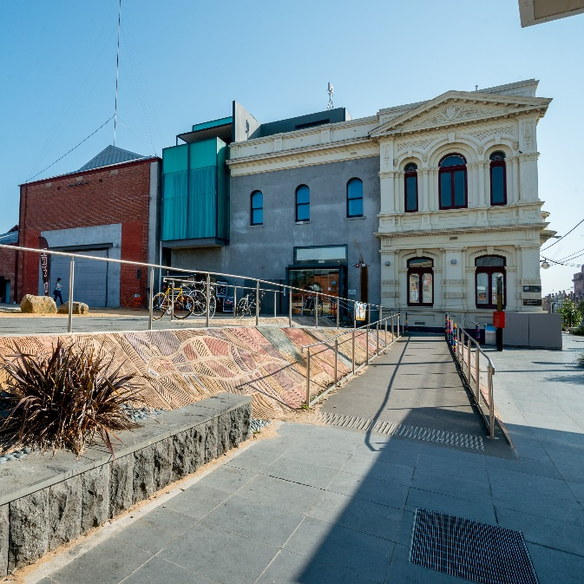

An accessible ramp is located next to the main building entrance. The entrance to the West Wing is one single level.

## Box Office

Once inside, the box office to the right of you. Here, our welcoming front of house staff will be available to provide any assistance you need.

## Ushers

Ushers will be wearing black with a Darebin City Council logo on the left shoulder and a blue lanyard around their neck.

## Kiosk

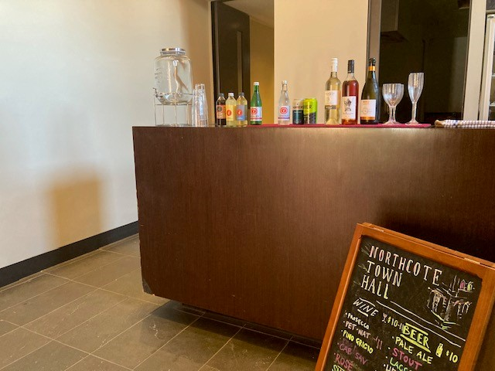

Drinks and snacks can be purchased at the kiosk and taken into the performance space.

There is a lower section of the kiosk which is wheelchair accessible.

The kiosk accepts card only, not cash.

## Toilets

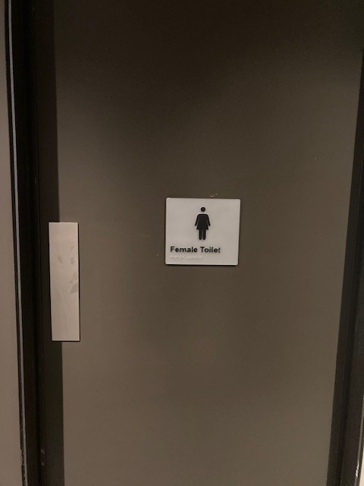 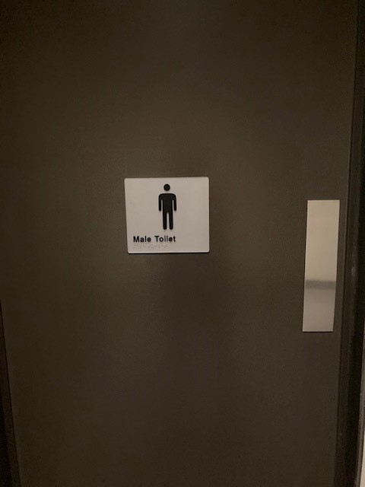

**Image**: The door to the designated male toilets within the West Wing.

**Image**: The door to the designated female toilets within the West Wing.

Designated toilets are located down the main hall of the West Wing and on the left.

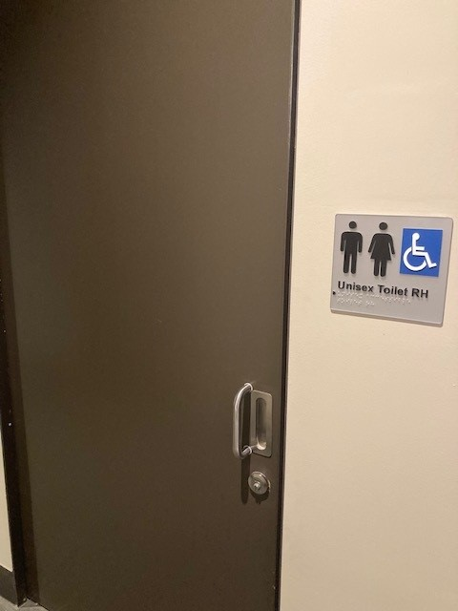

There is also an Accessible toilet in between the female and male toilets

All bathrooms have hand dryers with sensory activation.

Merch

The *FRITZ* team will be selling t-shirts and posters in the foyer.

Colouring In

There be a colouring in activity in the foyer for anyone interested to take part in.

Performance Space

When the performers are ready, the ushers will announce that the ‘house is open’. They will open the doors to Studio One, and you may enter at your own pace.

**Image**: Studio One seating area at Northcote Town Hall Arts Centre.

There is general seating for this event; there will be a mixture of chairs, beanbags and cushions available. An Usher can help you find a seat if you would like some help. An Usher will also be able to assist those needing wheelchair access into Studio One.

# **Getting to Northcote Town Hall Arts Centre**

## Public Transport Information

Northcote Town Hall Arts Centre is easily accessible by tram, train, bus, car and bike. Help reduce your environmental impact and rethink your need to drive.

## For help planning your tram, train or bus trip use the [PTV journey planner](https://www.ptv.vic.gov.au/journey).

## By Tram

No. 86 (get off at Stop: #31 - Northcote Town Hall/High St.)

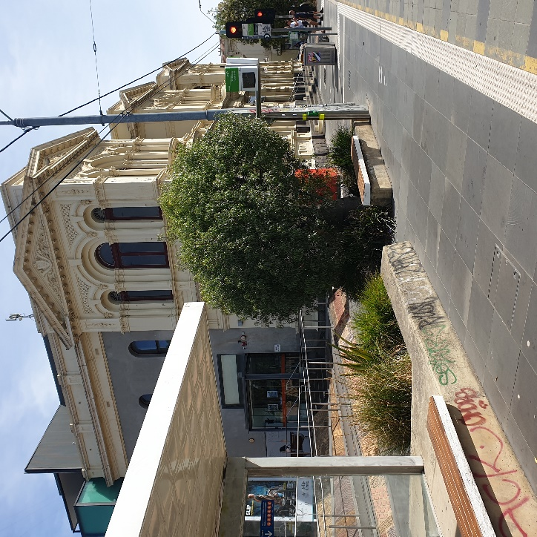

Image Description: Northcote Town Hall Tram Stop #31 (from City)

Accessibility: Level access stop. Tactile ground surface indicator, accessible ramp, lighting,

YarraTrams aims to run every service on Route 86 with a low-floor tram.

To find out if the next tram at your stop will be a low-floor tram, look for the wheelchair symbol on [tramTRACKER®](http://tramtracker.com/) or call 1300 MY TRAM (1300 698 726)

## By Train

The nearest station is Merri Station, which is a 10 min walk uphill, from the venue.

[Merri Station Information](https://www.ptv.vic.gov.au/journey/#JourneyPlannerForm:::lat=-37.7778435&lon=144.992981&origin=Merri%20Station&origin_id=1125&_auth=0642fe4d1eed8fce4ec2b672581564d726c9cc65079fb8516b5a6f3a7e404d32)

Or, Northcote Station, which is a 12 min walk from the venue

[**Northcote Station Information**](https://www.ptv.vic.gov.au/journey/#JourneyPlannerForm:::lat=-37.7698631&lon=144.995285&origin=Northcote%20Station&origin_id=1147&_auth=d7b8b28d9956c8032fe67b06b36faaa2e83196490f66b23c7fbf598f54f1f84d)

Or, Westgarth Station, which is a 12 min walk uphill, from the venue or you can catch the No. 86 Tram from Stop: #27 (Westgarth St/High St) on High St up the hill to the venue (Stop: #31 Northcote Town Hall/High St).

[**Westgarth Station Information**](https://www.metrotrains.com.au/stations/westgarth/)

## By Bus

Route 552 (get off at stop 235 Northcote Plaza, and a further 10-minute walk)

Route 508 (get off at stop 6170 Separation St/High St, and a further 10-minute walk)

Route 567 (get off stop 1036 Mitchell Street/High St, and a further 10-minute walk)

Route 250 and 251 (get off at Westgarth St/High St, and a further 10-minute walk up the hill)

## By Car

There are two sets of accessible car spaces around the venue: one on James Street, near the corner of High Street, and one on Westbourne Grove, near the corner of High Street.

**Parking and Disability Access Parking:**

Limited on-street parking is available on James Street, McIntosh Street and

Westbourne Grove.

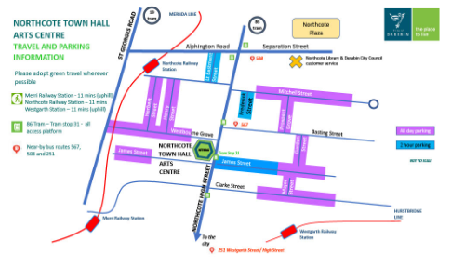

## Bike or foot

Northcote Town Hall Arts Centre is conveniently located along High Street, Northcote, which is ideal for cycling or walking.