**TANTRUM For 6**

by Harrison Ritchie-Jones  
Presented by Darebin Arts Speakeasy

Social Script

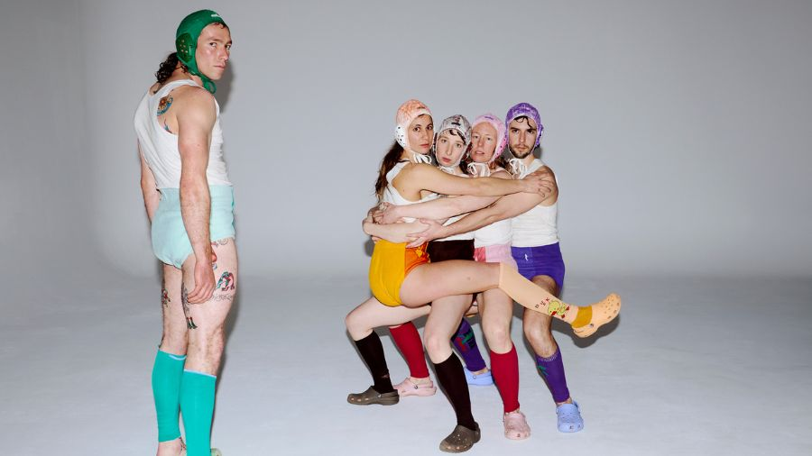

**Image credit**: Jo Duck

**Image description**: A group of people wearing colourful wrestling outfits and helmets huddle in a hug formation. A person stands separately from the group to the left side and looks at the camera from over their shoulder.

Table of Conte Rts

**Where** 3

**When** 3

**Access Services** 3

**Performers** 4

**Sensory Elements** 4

Sound 4

Lighting 4

Physical 4

Smell 5

Visual 5

Audience Experience 5

Shocks or surprises 5

Audience experience 6

**Other** 6

**Post-Show Artist Talk:** 6

**The Venue** 7

Front Entrance 7

Accessible Entrance 7

Box Office 8

Ushers 8

Bar 9

Toilets 10

Performance Space 11

**Getting to Northcote Town Hall Arts Centre** 12

Public Transport Information 12

For help planning your tram, train or bus trip use the PTV journey planner. 12

By Tram 12

By Train 13

By Bus 13

By Car 13

Bike or foot 14

# **Where**

Northcote Town Hall Arts Centre

189 High Street, Northcote Victoria 3070

# **When**

Wednesday 12 February, 7.30pm (preview)

Thursday 13 February, 7.30pm (opening)

Friday 14 February, 7.30pm

Saturday 15 February, 2pm

Saturday 15 February, 7.30pm

Wednesday 19 February, 7.30pm (post-show talk)

Thursday 20 February, 7.30pm

Friday 21 February, 7.30pm

Saturday 22 February, 2pm

Saturday 22 February, 7.30pm

Duration: 60mins without an interval

# **Access Services**

For more information or to let us know about your access needs, email the ticketing team: [Ticketing@darebin.vic.gov.au](mailto:Ticketing@darebin.vic.gov.au)



The performance is wheelchair accessible.



Northcote Town Hall Arts Centre has accessible toilets on site.



You can book your complimentary companion ticket online or over the phone when purchasing tickets to any show. Contact our box office team for more information.

# **Performers**

There are 6 performers.

Harrison Ritchie-Jones Anika De Ruyter Rebecca Jensen

Georgia Rudd Oliver Savariego Michaela Tancheff

# **Sensory Elements**

Content warnings – This production uses strobe effects, loud noise, haze and baby powder.

## Sound

The following sounds from music tracks will occur in order during the show

1. Abstract contemporary music – organ, choir – reflective/sad meaningful
2. High pitched voices – sound modulation – sinister kids
3. Spooky classic 90s music – tense brewing scary
4. Dark sin trance music elements of house music
5. Rain and thunder – nature
6. Return to abstract organ

## Lighting

The following lighting ques will occur in order during the show

1. Dark concentrated – pastels – blue to yellow and green
2. Brightens
3. Transitions to strobing underground feel
4. To cinematic movie
5. Ending with witching hour feel – purple haze

## Physical

Once the doors to the Main Hall are opened, the audience will make their way to their seats. Some audience members can choose to sit on the floor in front of the seating bank where cushions will be provided. If you require a seat, please speak to an Usher upon arrival.

## Smell

The show requires a lot of physical movement from the performers. Audience may smell their sweat.

## Visual

There will be three digital screens behind the performers, which will project video on them to make one large cinematic screen. These scenes are pre-recorded clips referencing Sci-Fi movies.

## Audience Experience

**Entry to Space**

The audience will enter the Main Hall from the main doors in foyer.

The performance space will be open 5 minutes prior to start time.

Audiences will be allowed to sit wherever they prefer on the seating bank.

The Main Hall doors will close at the performance start time.

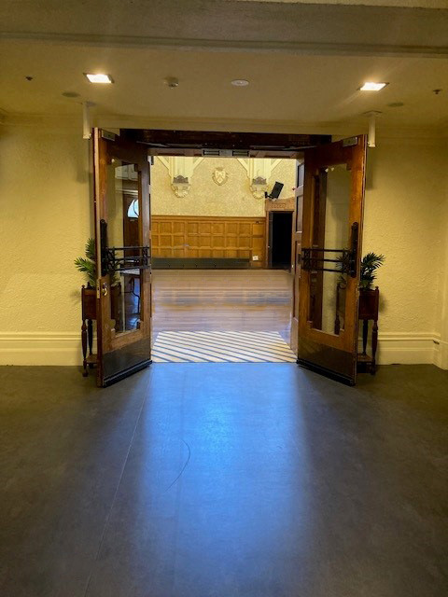

**Image**: The entrance into the Main Hall at Northcote Town Hall Arts Centre.

## Shocks or surprises

There will be some loud noises from music playing during dramatic scene changes.

## Audience experience

This performance is designed to allow the audience to feel a mix of emotions. These emotions may include reflection, inspiration, energising.

# **Other**

Dynamic Lighting - This performance contains strobe effects and projections directed towards the audience.

High Contrast Image Changes – There will be some elements of contrasting lighting to create dark to light moments.

General Notes

An Acknowledgement of Country will be said by a Darebin staff member before the doors to the Main Hall open.

# **Post-Show Artist Talk:**

After the **Thursday 19 February 7:30pm performance** there will be an optional **post-show talk** with the artists, on the same stage. There will be a short break between the performance and the talk.

If you do not wish to stay for the post-show talk there is no obligation. You are most welcome to stay or leave.

# **The Venue**

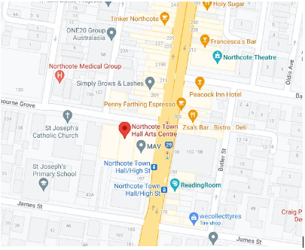

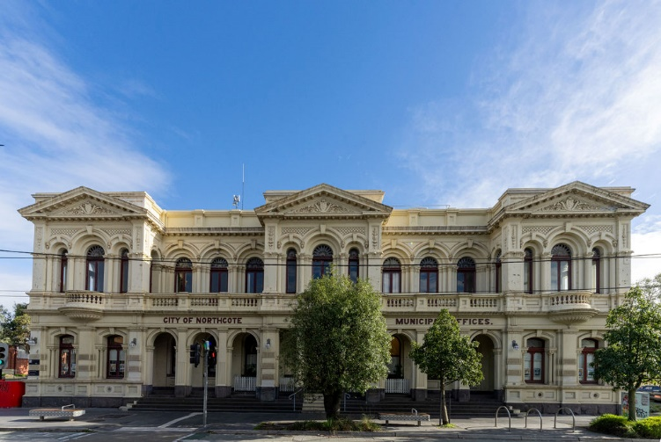

Image: a map of Northcote Town Hall Arts Centre and its surrounding area. [Map](https://www.google.com/maps/place/Northcote+Town+Hall+Arts+Centre/@-37.7744444,144.9975,15z/data=!4m2!3m1!1s0x0:0x4695de3e1d26cbc7?sa=X&ved=1t:2428&ictx=111)

Image: Northcote Town Hall Arts Centre as seen from High St, Northcote

## Front Entrance

At Northcote Town Hall Arts Centre, the main entrance is up the steps to the side of the building off High St. There are nine steps equipped with grab rails and tactile surface indicators at the top and bottom of each step.

The entrance to the West Wing is beyond the main building entrance. The West Wing is where Studio One is located.

## Accessible Entrance

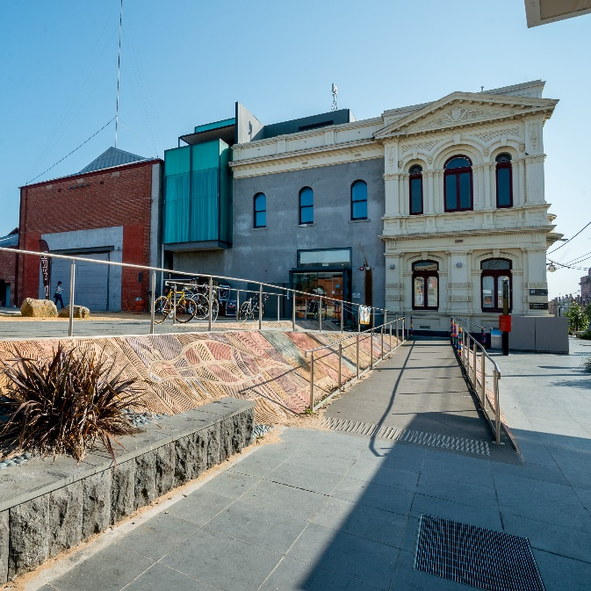

An accessible ramp is located next to the main building entrance. The entrance to the West Wing is one single level.

## Box Office

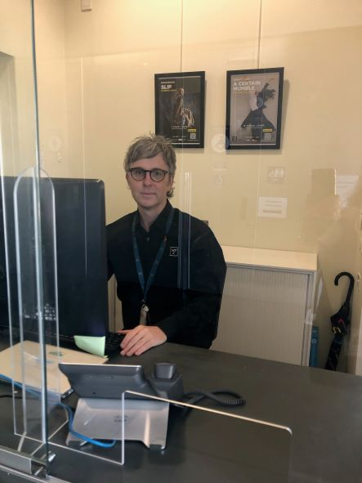

Once inside, the box office to the right of you. Here, our welcoming front of house staff will be available to provide any assistance you need.

## Ushers

Ushers will be wearing black with a Darebin City Council logo on the left shoulder and a blue lanyard around their neck.

## Bar

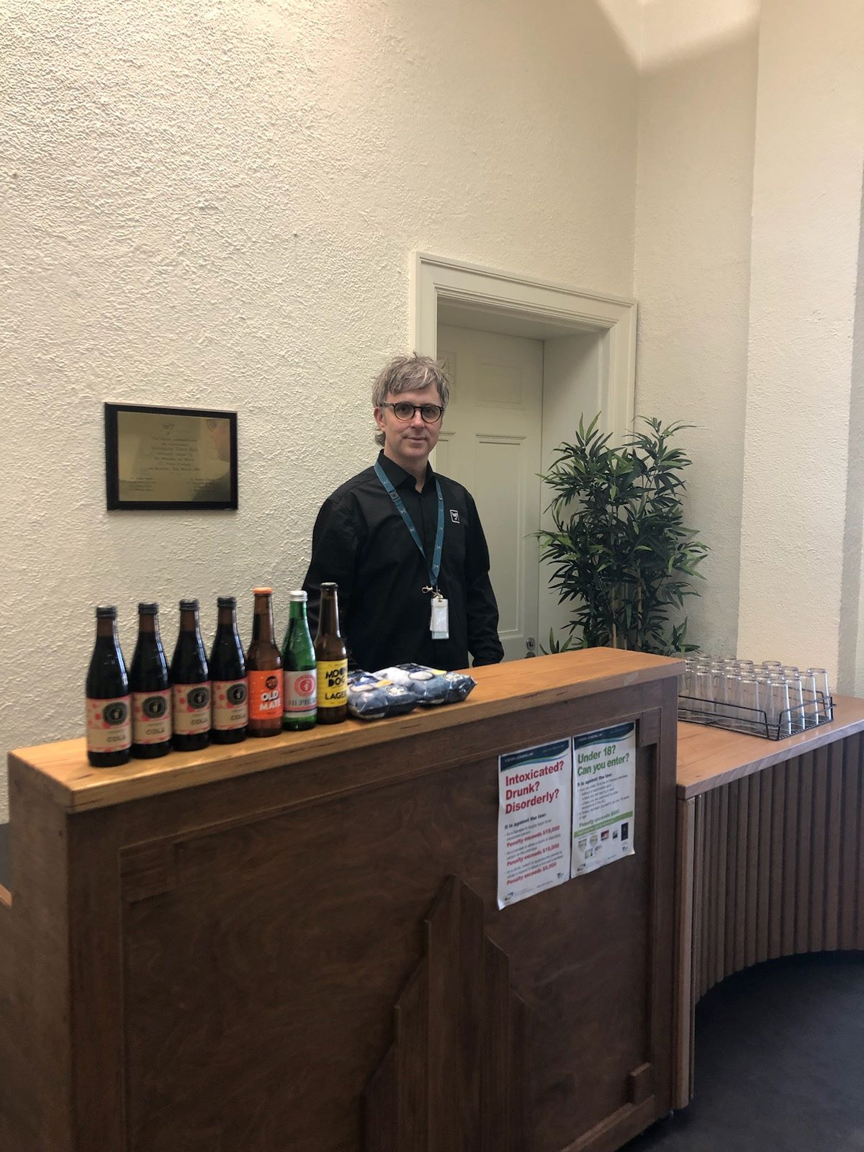

Drinks and snacks can be purchased at the bar and taken into the theatre.

There is a lower section of the bar which is wheelchair accessible.

The bar accepts card only, not cash.

## Toilets

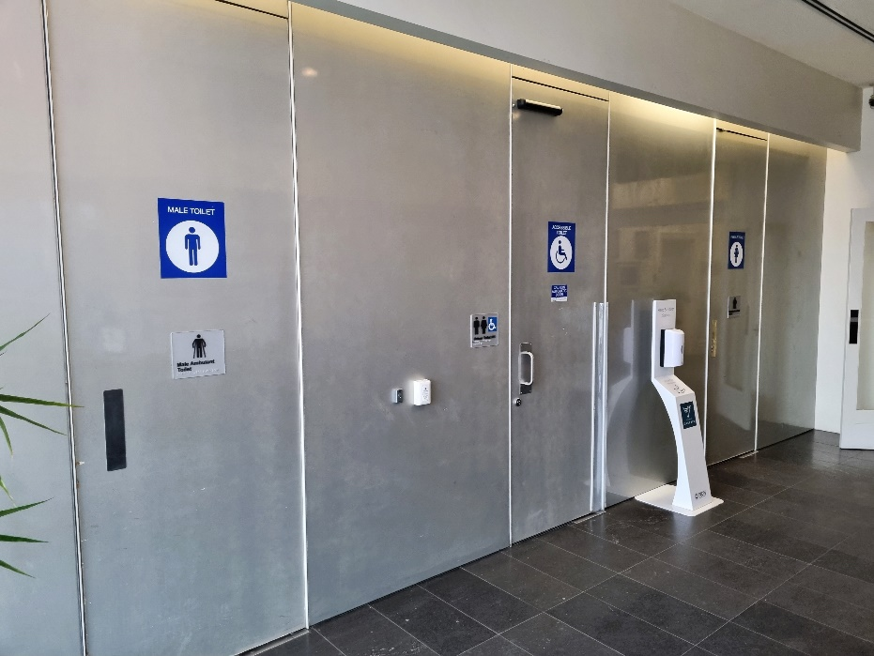

Designated toilets are located down the main hall of the West Wing and on the left.

All bathrooms have hand dryers with sensory activation.

## Performance Space

When the performers are ready, the ushers will announce that the ‘house is open’. They will open the doors to the Main Hall, and you may enter at your own pace.

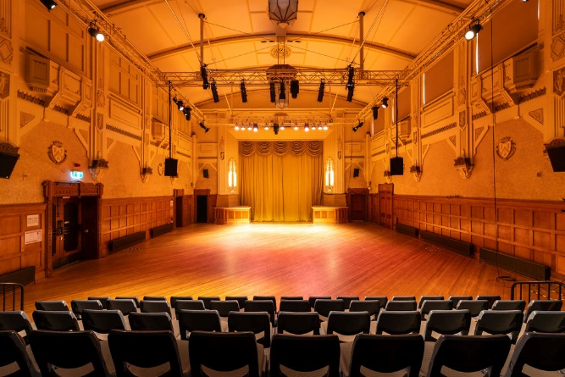

**Image**: A large art deco hall with seating area in the front.

There is general seating for this event. An Usher can help you find a seat if you would like some help. An Usher will also be able to assist those needing wheelchair access into Studio One.

# **Getting to Northcote Town Hall Arts Centre**

## Public Transport Information

Northcote Town Hall Arts Centre is easily accessible by tram, train, bus, car and bike. Help reduce your environmental impact and rethink your need to drive.

## For help planning your tram, train or bus trip use the [PTV journey planner](https://www.ptv.vic.gov.au/journey).

## By Tram

No. 86 (get off at Stop: #31 - Northcote Town Hall/High St.)

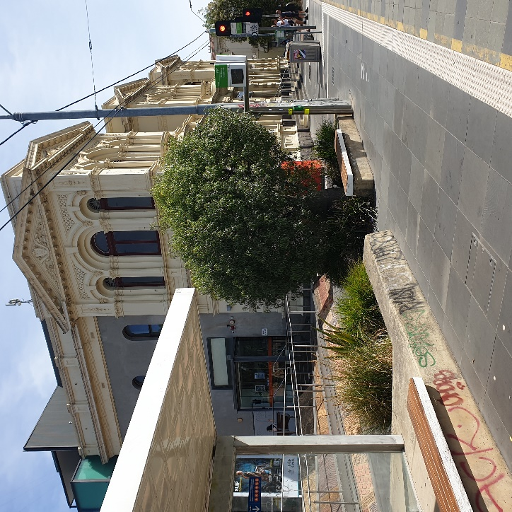

Image Description: Northcote Town Hall Tram Stop #31 (from City)

Accessibility: Level access stop. Tactile ground surface indicator, accessible ramp, lighting,

YarraTrams aims to run every service on Route 86 with a low-floor tram.

To find out if the next tram at your stop will be a low-floor tram, look for the wheelchair symbol on [tramTRACKER®](http://tramtracker.com/) or call 1300 MY TRAM (1300 698 726)

## By Train

The nearest station is Merri Station, which is a 10 min walk uphill, from the venue.

[Merri Station Information](https://www.ptv.vic.gov.au/journey/#JourneyPlannerForm:::lat=-37.7778435&lon=144.992981&origin=Merri%20Station&origin_id=1125&_auth=0642fe4d1eed8fce4ec2b672581564d726c9cc65079fb8516b5a6f3a7e404d32)

Or, Northcote Station, which is a 12 min walk from the venue

[**Northcote Station Information**](https://www.ptv.vic.gov.au/journey/#JourneyPlannerForm:::lat=-37.7698631&lon=144.995285&origin=Northcote%20Station&origin_id=1147&_auth=d7b8b28d9956c8032fe67b06b36faaa2e83196490f66b23c7fbf598f54f1f84d)

Or, Westgarth Station, which is a 12 min walk uphill, from the venue or you can catch the No. 86 Tram from Stop: #27 (Westgarth St/High St) on High St up the hill to the venue (Stop: #31 Northcote Town Hall/High St).

[**Westgarth Station Information**](https://www.metrotrains.com.au/stations/westgarth/)

## By Bus

Route 552 (get off at stop 235 Northcote Plaza, and a further 10-minute walk)

Route 508 (get off at stop 6170 Separation St/High St, and a further 10-minute walk)

Route 567 (get off stop 1036 Mitchell Street/High St, and a further 10-minute walk)

Route 250 and 251 (get off at Westgarth St/High St, and a further 10-minute walk up the hill)

## By Car

There are two sets of accessible car spaces around the venue: one on James Street, near the corner of High Street, and one on Westbourne Grove, near the corner of High Street.

**Parking and Disability Access Parking:**

Limited on-street parking is available on James Street, McIntosh Street and

Westbourne Grove.

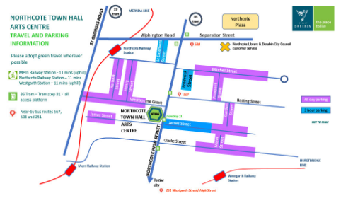

## Bike or foot

Northcote Town Hall Arts Centre is conveniently located along High Street, Northcote, which is ideal for cycling or walking.