**Djuna**

by Eva Rees, produced by Bullet Heart Club  
Presented by Darebin Arts Speakeasy

Social Script

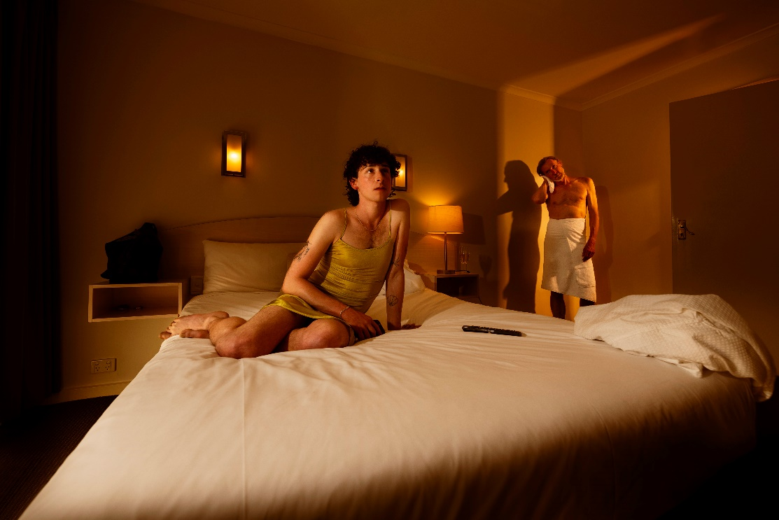

**Image credit**: Meagan Harding

**Image description**: A person wearing a gold slim dress sits on a bed looking outwards beyond the camera. In the background, a person wearing a white towel around their waist with head tilted to the left watches the person on the bed.

Table of Contents

**Where** 4

**When** 4

**Access Services** 4

**Sensory Elements** 5

Sound Description 5

Lighting and Audio Description 5

Physical Description 6

Smell 6

Visual (Set & Props) 6

Audience Experience 7

Shocks or surprises 8

Audience experience 8

Social expectations 8

Performance expectations 9

**Post-Show Artist Talk:** 9

**The Venue** 10

Front Entrance 10

Accessible Entrance 11

Box Office 11

Ushers 11

Bar 12

Toilets 12

Performance Space 14

**Getting to Northcote Town Hall Arts Centre** 15

Public Transport Information 15

For help planning your tram, train or bus trip use the PTV journey planner. 15

By Tram 15

By Train 16

By Bus 16

By Car 16

Bike or foot 17

# **Where**

Northcote Town Hall Arts Centre

189 High Street, Northcote Victoria 3070

# **When**

Wednesday 12 March, 7.30pm (preview)

Thursday 13 March, 7.30pm (opening)

Friday 14 March, 7.30pm

Saturday 15 March, 7.30pm

Sunday 16 March, 5pm

Wednesday 19 March, 7:30pm (post-show talk)

Thursday 20 March, 7.30pm (Auslan Interpreted Performance)  
* Due to unforeseen circumstance, this event will not be Auslan interpreted

Friday 21 March, 7.30pm

Saturday 22 March, 7.30pm

Sunday 23 March, 5pm

Duration: 95mins without an interval

# **Access Services**

For more information or to let us know about your access needs, email the ticketing team: [Ticketing@darebin.vic.gov.au](mailto:Ticketing@darebin.vic.gov.au)



The performance is wheelchair accessible.



Northcote Town Hall Arts Centre has accessible toilets on site.



You can book your complimentary companion ticket online or over the phone when purchasing tickets to any show. Contact our box office team for more information.

**Performers**

There are 4 performers.

Jay Gold Dion Mills

Cherri Anderson Rebekah Maisano

# **Sensory Elements**

Content Warnings: Djuna is a thriller/horror production suitable for patrons 18+. This production contains loud noises, flashing lights, strong language, mature themes, haze, frontal nudity, references to self-harm, graphic depiction of violence and blood, the use of herbal cigarettes. There will be no admittance once the event begins.

## Sound Description

* There is loud music and sudden noises.
* Sound goes across a wide sonic range including deep resonant bass notes, high pitched crashes, scratchy tape noises and fuzzy vibrations.
* Loud electronic music plays between scenes, and there are loud buzz sounds when characters exit and enter in blackouts.
* There is the sound of water dripping, fans and air-condition units.
* The music gives a feeling of an unrelenting build and sustain.
* The overall feel is creepy and uncomfortable with bass drops, smashing glass and horror screams.

## Lighting and Audio Description

* There are several sudden black outs, flashing lights, pulsing lights and strobe-like moments.
* Haze is used in the theatre, creating a smoky atmosphere.
* Red, blue and green colour palettes dominate.
* There is dramatic lighting across the stage space throughout, with lots of darkness contrasted with areas of light.
* Projection includes high contrast bold colour blocks that flash to the beat of the music.
* Lots of quick changes from one lighting state to another.
* Words and images screen across a curtain, in the style of cult/exploitation films.
* Lines and colours ooze and swirl across the stage.

## Physical Description

* There is nudity.
* Depictions of someone being drugged and tied up.
* Depictions of violence, including horseplay going too far, strangulation and the mutilation of male genitals, with fake blood spurting out.
* Depictions of BDSM submissive and dominant encounters.
* Predatory male toxic behaviour.
* Performed usage of alcohol and drugs.
* Conversations around trans lived experiences, including the challenges of gender-affirming care.
* Conversations around human suffering, climate change statistics and civil unrest.

## Smell

* The cast light 4 herbal cigarettes. Herbal cigarettes contain marshmallow root, passionflower, cloves, or jasmine. There is a moderately spicy smell with undertones of anise and citrus.
* A hotel cleaner sprays air freshener in the theatre.
* Canned salmon is open on stage and can be smelt in the auditorium.

## Visual (Set & Props)

* The set is a strange hotel room. There is a bed, a red table with an office chair on wheels and a red occasional chair.
* The stage floors are painted a mint colour.
* The hanging curtains are a mix of fleshy, orange, red and brown colours.
* There is a flesh-like back wall feature, that people go behind and manipulate.
* In the flesh-like wall is an air vent that slime comes out of. The slime is the colour of sickly phlegm.
* Suspended from the ceiling is a hanging light feature that changes colours including ultraviolet light.
* The actors carry champagne and beer glasses. Liquids spill on the stage.
* The hotel cleaners bring on sex toys and they sometimes wear gas masks.

## Audience Experience

* Djuna is a trans thriller which takes place in a hotel room. The experience is creepy. The story has slow reveals through conversations between two main characters.
* The hotel room is responsive and reacts to the events happening in the room.
* Everything is heightened and queer, giving the feel of some of our favourite body horror films.

**Entry to Space**

The audience will enter Studio One from the main doors in foyer.

The performance space will be open 5 minutes prior to start time.

Audiences will be allowed to sit wherever they prefer on the seating bank.

The Studio One doors will close at the performance start time.

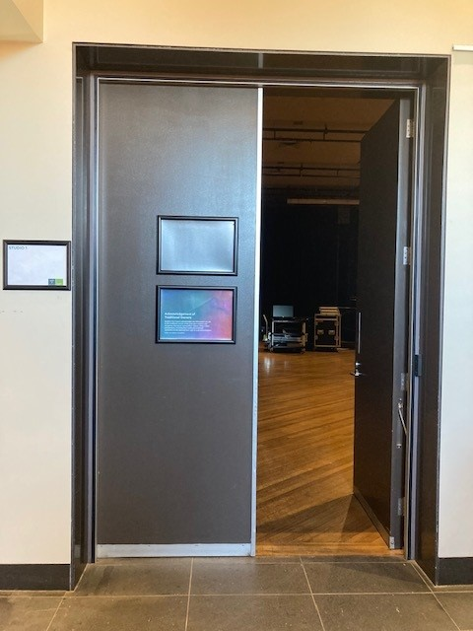

**Image**: The entrance Studio One at Northcote Town Hall Arts Centre.

## Shocks or surprises

* A masked figure appears behind a glass panel.
* PLOT SPOILER: Djuna is lying about her age and who she is.
* PLOT SPOILER: Marcus hides his job and who he really is from Djuna.
* PLOT SPOILER: Djuna and Marcus have come to the hotel to live out their fantasies. For Djuna this is exploring transness in a dominant and submissive sexual experience with an older man. For Marcus he gains sexual pleasure in controlling and manipulating a young person's transition.
* PLOT SPOILER: When Marcus suggests he can do Djuna’s gender-affirming surgery in the hotel room, Djuna drugs, then ties Marcus up. Djuna cuts off Marcus’ penis at the end of the play.

## Audience experience

* The show is like watching a thriller on TV. The only difference is that it’s performed live in a theatre.
* This performance may make you feel like you do not know how to respond to what is happening on stage. You may jump at a scary moment or laugh or respond however you like – that is the fun of watching a thriller!
* There is no audience interaction. All action takes place on the stage/set.
* The theatre is a small room. If you choose to sit in the front row, you will be in close proximity to the performers, within 2 meters.

## Social expectations

* At the theatre there will be ushers who you can talk to ask for help and any questions.
* There is no allocated seating for this performance. The theatre has a seating bank where you can choose your seat. Please let the front of house staff know if you would be most comfortable in a particular spot before the doors open.
* There is a short lock out (or lock in) for this performance for the first part of the show due to a blackout sequence. An usher will let you know when you can enter the theatre.
* We ask that you stay seated during the performance.
* You are welcome to leave the theatre, we only ask that as the show has a number of sudden blackouts, if you are moving and a blackout happens, please stay still until the lights come back up before moving again.
* You are welcome to come and go as you please to access the bathrooms and quiet space.

## Performance expectations

* There is dialogue throughout the show, both live and recorded as news reports on TV.
* The story follows a narrative arc over multiple meetings over two years in one hotel room.
* There are five scenes.
* There are four people performing on stage. Two performers play the main characters Djuna and Marcus. The other two are cleaners in the hotel.

General Notes

An Acknowledgement of Country will be said by a Darebin staff member before the doors to Studio 1 open.

# **Post-Show Artist Talk:**

After the **Wednesday 19 March 7:30pm performance** there will be an optional **post-show talk** with the artists, on the same stage. There will be a short break between the performance and the talk.

If you do not wish to stay for the post-show talk there is no obligation. You are most welcome to stay or leave.

# **The Venue**

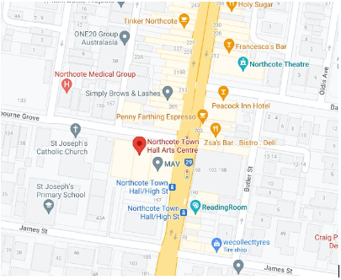

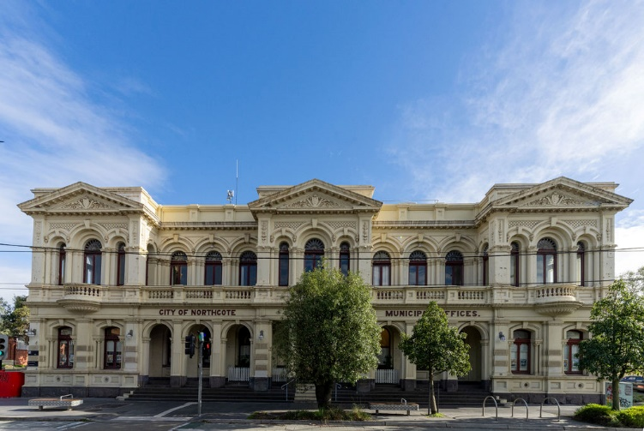

Image: a map of Northcote Town Hall Arts Centre and its surrounding area. [Map](https://www.google.com/maps/place/Northcote+Town+Hall+Arts+Centre/@-37.7744444,144.9975,15z/data=!4m2!3m1!1s0x0:0x4695de3e1d26cbc7?sa=X&ved=1t:2428&ictx=111)

Image: Northcote Town Hall Arts Centre as seen from High St, Northcote

## Front Entrance

At Northcote Town Hall Arts Centre, the main entrance is up the steps to the side of the building off High St. There are nine steps equipped with grab rails and tactile surface indicators at the top and bottom of each step.

**Image**: The West Wing entrance at Northcote Town Hall Arts Centre.

The entrance to the West Wing is beyond the main building entrance. The West Wing is where Studio One is located.

## Accessible Entrance

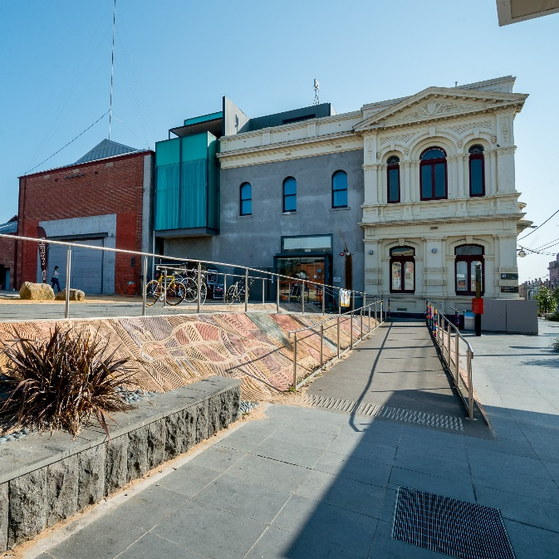

An accessible ramp is located next to the main building entrance. The entrance to the West Wing is one single level.

## Box Office

Once inside, the box office to the right of you. Here, our welcoming front of house staff will be available to provide any assistance you need.

## Ushers

Ushers will be wearing black with a Darebin City Council logo on the left shoulder and a blue lanyard around their neck.

## Bar

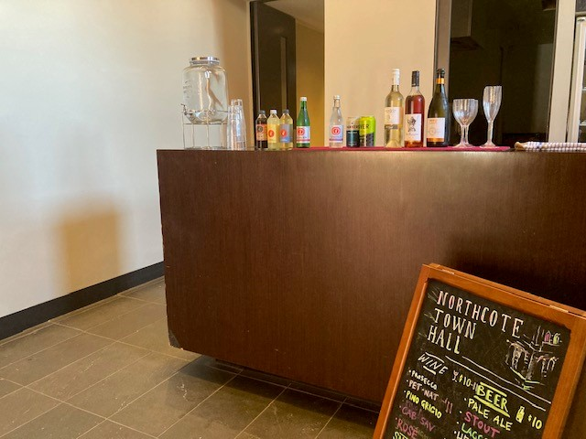

Drinks and snacks can be purchased at the bar and taken into the theatre.

There is a lower section of the bar which is wheelchair accessible.

The bar accepts card only, not cash.

## Toilets

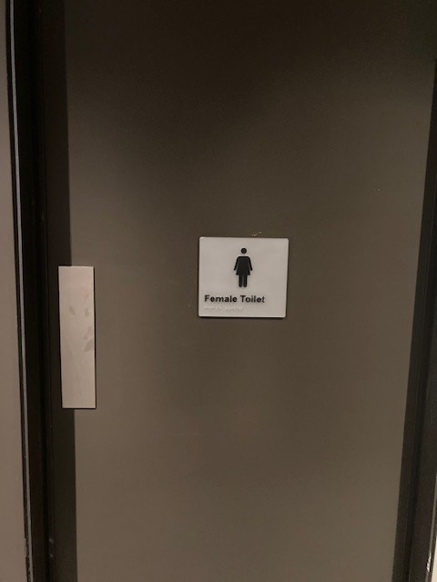 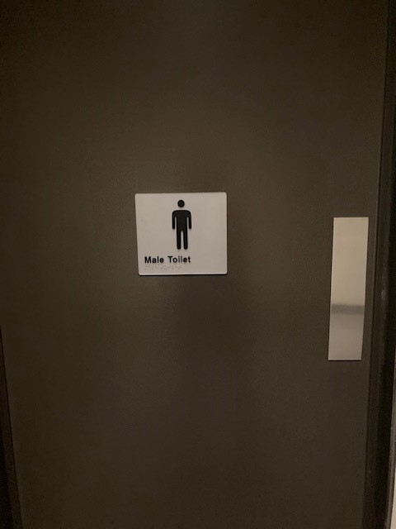

**Image**: The entrance to the Male toilets in the West Wing at Northcote Town Hall Arts Centre.

**Image**: The entrance to the Female toilets in the West Wing at Northcote Town Hall Arts Centre.

Designated toilets are located down the main hall of the West Wing and on the left.

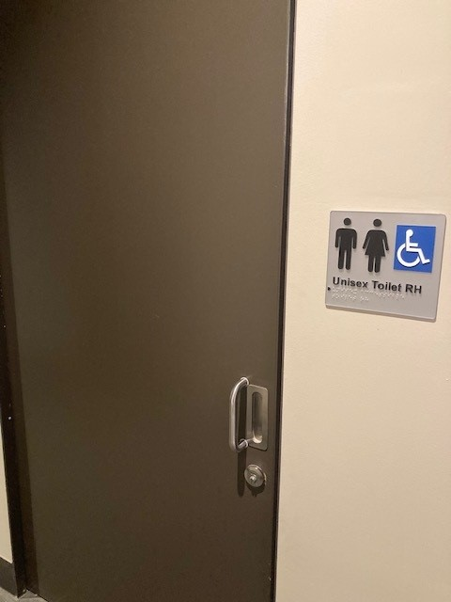

**Image**: The entrance to the Accessible toilets in the West Wing at Northcote Town Hall Arts Centre.

There is also an Accessible toilet in between the female and male toilets

All bathrooms have hand dryers with sensory activation.

## Performance Space

When the performers are ready, the ushers will announce that the ‘house is open’. They will open the doors Studio One, and you may enter at your own pace.

**Image**: Studio One performance space from the audience seating.

There is general seating for this event. An Usher can help you find a seat if you would like some help. An Usher will also be able to assist those needing wheelchair access into Studio One.

# **Getting to Northcote Town Hall Arts Centre**

## Public Transport Information

Northcote Town Hall Arts Centre is easily accessible by tram, train, bus, car and bike. Help reduce your environmental impact and rethink your need to drive.

## For help planning your tram, train or bus trip use the [PTV journey planner](https://www.ptv.vic.gov.au/journey).

## By Tram

No. 86 (get off at Stop: #31 - Northcote Town Hall/High St.)

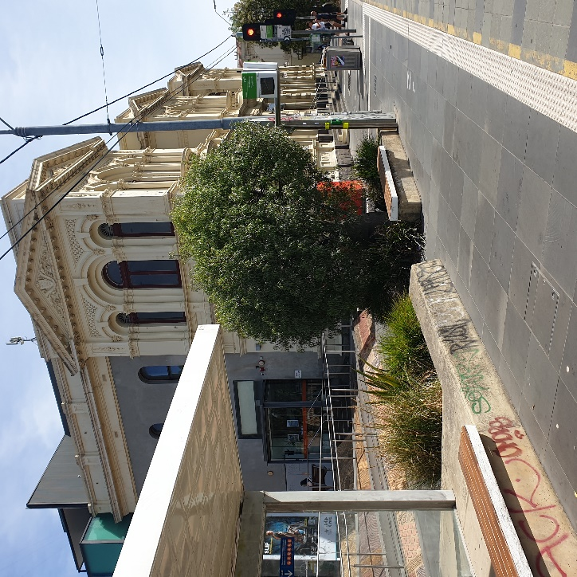

Image Description: Northcote Town Hall Tram Stop #31 (from City)

Accessibility: Level access stop. Tactile ground surface indicator, accessible ramp, lighting,

YarraTrams aims to run every service on Route 86 with a low-floor tram.

To find out if the next tram at your stop will be a low-floor tram, look for the wheelchair symbol on [tramTRACKER®](http://tramtracker.com/) or call 1300 MY TRAM (1300 698 726)

## By Train

The nearest station is Merri Station, which is a 10 min walk uphill, from the venue.

[Merri Station Information](https://www.ptv.vic.gov.au/journey/#JourneyPlannerForm:::lat=-37.7778435&lon=144.992981&origin=Merri%20Station&origin_id=1125&_auth=0642fe4d1eed8fce4ec2b672581564d726c9cc65079fb8516b5a6f3a7e404d32)

Or, Northcote Station, which is a 12 min walk from the venue

[**Northcote Station Information**](https://www.ptv.vic.gov.au/journey/#JourneyPlannerForm:::lat=-37.7698631&lon=144.995285&origin=Northcote%20Station&origin_id=1147&_auth=d7b8b28d9956c8032fe67b06b36faaa2e83196490f66b23c7fbf598f54f1f84d)

Or, Westgarth Station, which is a 12 min walk uphill, from the venue or you can catch the No. 86 Tram from Stop: #27 (Westgarth St/High St) on High St up the hill to the venue (Stop: #31 Northcote Town Hall/High St).

[**Westgarth Station Information**](https://www.metrotrains.com.au/stations/westgarth/)

## By Bus

Route 552 (get off at stop 235 Northcote Plaza, and a further 10-minute walk)

Route 508 (get off at stop 6170 Separation St/High St, and a further 10-minute walk)

Route 567 (get off stop 1036 Mitchell Street/High St, and a further 10-minute walk)

Route 250 and 251 (get off at Westgarth St/High St, and a further 10-minute walk up the hill)

## By Car

There are two sets of accessible car spaces around the venue: one on James Street, near the corner of High Street, and one on Westbourne Grove, near the corner of High Street.

**Parking and Disability Access Parking:**

Limited on-street parking is available on James Street, McIntosh Street and

Westbourne Grove.

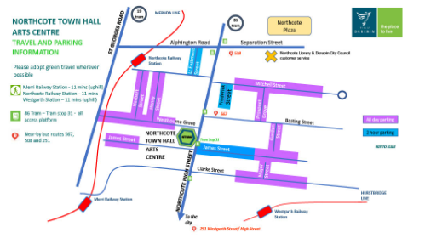

## Bike or foot

Northcote Town Hall Arts Centre is conveniently located along High Street, Northcote, which is ideal for cycling or walking.